PLEASE READ!!

HELENA LABORATORIES
PROCEDURE DOWNLOAD END USER AGREEMENT

In response to customer requests, Helena is pleased to provide the text for procedural package inserts in a digital format editable for your use. The text for the procedure you requested begins on page three of this document. Helena procedures contain the content outlined in the NCCLS (GP2-A#) format, except in the order sequence required by FDA regulations. As the NCCLS format is a guideline, you may retain these procedures as developed by the manufacturer (adding your title/authorization page) or manipulate the text file to produce your own document, matching the NCCLS section order exactly, if preferred.

We also provide the procedure in an Adobe Acrobat PDF format for download at www.helena.com as a “MASTER” file copy. Below are the specifications and requirements for using these digital files. Following the specifications is the procedure major heading sequence as given in the FDA style. Where there is a difference in order, or other notation in the outline, this will be indicated in braces { }.

WHAT YOU NEED TO KNOW:

1) These files represent the most current revision level to date. Your current product inventory could contain a previous revision level of this procedure.

2) The Microsoft Word document provides the text only from the master procedure, in a single-column format.

- It may not contain any illustrations, graphics or captions that may be part of the master procedure included in the kit.

- The master procedure may have contained special formatting characters, such as subscripts, superscripts, degree symbols, mean symbols and Greek characters such as alpha, beta, gamma, etc. These symbols may or may not display properly on your desktop.

- The master procedures may also contain columns of tabbed data. Tab settings may or may not be displayed properly on your desktop.

3) The Adobe Acrobat PDF file provides a snapshot of the master procedure in a printable 8.5 x 11” format. It is provided to serve as a reference for accuracy.

4) By downloading this procedure, your institution is assuming responsibility for modification and usage.
HELENA LABORATORIES
PROCEDURE DOWNLOAD END USER AGREEMENT

HELENA LABORATORIES LABELING – Style/Format Outline

1) PRODUCT {Test} NAME
2) INTENDED USE and TEST TYPE (qualitative or qualitative)
3) SUMMARY AND EXPLANATION
4) PRINCIPLES OF THE PROCEDURE
{NCCLS lists SAMPLE COLLECTION/HANDLING next}
5) REAGENTS (name/concentration; warnings/precautions; preparation; storage; environment; Purification/treatment; indications of instability)
6) INSTRUMENTS required – Refer to Operator Manual (... for equipment for; use or function; Installation; Principles of operation; performance; Operating Instructions; Calibration* {*is next in order for NCCLS – also listed in “PROCEDURE”}’ precautions/limitations/hazards; Service and maintenance information
7) SAMPLE COLLECTION/HANDLING
8) PROCEDURE
{NCCLS lists QUALITY CONTROL (QC) next}
9) RESULTS (calculations, as applicable; etc.)
10) LIMITATIONS/NOTES/INTERFERENCES
11) EXPECTED VALUES
12) PERFORMANCE CHARACTERISTCS
13) BIBLIOGRAPHY (of pertinent references)
14) NAME AND PLACE OF BUSINESS OF MANUFACTURER
15) DATE OF ISSUANCE OF LABELING (instructions)

For Sales, Technical and Order Information, and Service Assistance,
call Helena Laboratories toll free at 1-800-231-5663.

Form 364
Helena Laboratories
1/2006 (Rev 3)

SPIFE® Nexus Split Beta SPE Procedure in Combination with Template Urine Application

Cat. No. 2420, 2421, 2422

INTENDED USE
The SPIFE Nexus Split Beta SPE method is intended to quantitatively determine the presence of normal and abnormal serum proteins and qualitatively determine the presence of urine proteins by agarose electrophoresis using the SPIFE Nexus System.
For In Vitro Diagnostic Use Only.
Rx Only
SUMMARY
Serum contains over one hundred individual proteins, with specific functions and various concentrations under different pathologic conditions.¹ Since introduction of moving-boundary electrophoresis by Tiselius² and the subsequent use of zone electrophoresis, serum proteins have been fractionated on the basis of their electrical charge at a particular pH into five classical fractions: albumin, alpha₁, alpha₂, beta and gamma proteins. Each of these classical electrophoretic zones, with the exception of albumin, normally contains two or more components. Knowing the relative proportions of these fractions has proven useful in the diagnosis and prognosis of certain disease states.^{3,4,5}
PRINCIPLE
Proteins are large molecules composed of covalently linked amino acids. Depending on electron distributions resulting from covalent or ionic bonding of structural subgroups, proteins can be either polar or nonpolar at a given pH. Proteins are separated according to their respective electrical charges on agarose gel using both the electrophoretic and electroendosmotic forces present in the system. The proteins are then stained with a visible stain.
REAGENTS
1. SPIFE Split Beta SPE Gel
Ingredients: Each gel contains agarose in a tris-barbital/MOPS buffer with calcium lactate, a stabilizer, and a preservative.
WARNING: FOR IN-VITRO DIAGNOSTIC USE ONLY. The gel contains barbital which, in sufficient quantity, can be toxic.
Preparation for Use: The gels are ready for use as packaged.
Storage and Stability: The gels should be stored at room temperature (15 to 30°C) and are stable until the expiration date indicated on the package. The gels must be stored horizontally in the protective packaging in which they are shipped. DO NOT REFRIGERATE OR FREEZE THE GELS. Avoid storage close to a window or heat source, and avoid temperature variation during storage.
Signs of Deterioration: Any of the following conditions may indicate deterioration of the gel: (1) crystalline appearance indicating the agarose has been frozen, (2) cracking and peeling indicating drying of the agarose, (3) bacterial growth indicating contamination, (4) thinning of the gel blocks.
2. SPIFE Nexus Blue
Ingredients: The stain contains 0.5% (w/v) acid blue stain, 5% acetic acid, and surfactant.
WARNING: FOR IN-VITRO DIAGNOSTIC USE ONLY. DO NOT INGEST.
Preparation for Use: The stain is ready for use as packaged.
Storage and Stability: The stain solution is stable for one year when stored at 15 to 30°C in a closed container.
Signs of Deterioration: The prepared stain should be a homogeneous mixture free of precipitate. Discard if precipitate forms.
3. Citric Acid Destain
Ingredients: After dissolution, destain contains 0.3% (w/v) citric acid.
WARNING: FOR IN-VITRO DIAGNOSTIC USE. DO NOT INGEST - IRRITANT.
Preparation for Use: Pour 11 L of deionized water into Destain vat. Add full package of destain and mix until completely dissolved.
Storage and Stability: Store the destain at 15 to 30°C. It is stable until the expiration date on the package.
Signs of Deterioration: Discard if solution becomes cloudy.
INSTRUMENT
A SPIFE Nexus analyzer must be used to apply serum samples, electrophorese, stain, destain, dry and then scan the gels. The gels may also be scanned on a separate densitometer such as the QuickScan Touch Plus (Cat. No. 1640). Refer to the Operator's Manuals for detailed instructions.
SPECIMEN COLLECTION AND HANDLING
Specimen: Fresh serum or urine is the specimen of choice. Use of plasma will cause a fibrinogen band to appear as a distinct narrow band between the beta and gamma fractions.
Storage and Stability: If storage is necessary, store serum samples covered at 15 to 30°C for 4 days, 2 to 8°C for 2 weeks or -20°C for 6 months.⁶ Urine samples may be stored covered at 2 to 8°C for up to 9 days or at -20°C for 1 month. Samples should be discarded if there are signs of contamination, marked turbidity or gross hemolysis. It is the responsibility of the individual laboratory to use all available references and/or its own studies to determine specific stability criteria for its laboratory.
Interfering Factors:
1. Hemolysis may cause false elevation in the alpha₂ and beta fractions.
2. Uncovered specimens may yield inaccurate results due to evaporation.
PROCEDURE
Materials provided: The following materials needed for the procedure are contained in the SPIFE Nexus Split Beta SPE Kit. Individual items are not available.
Test Size Cat. No.
60 Samples 2420
40 Samples 2421
20 Samples 2422
Cat. No. 2420, 2421, 2422
SPIFE Split Beta SPE Gels (10)
SPIFE Nexus Blue (1 vial)
SPIFE Blotter C (10)
Citric Acid Destain (1 pkg)
Serrated Blade Applicator Kit, 20 Sample (10/20/30)
Materials provided but not contained in the kit:
Item Cat. No.
SPIFE Nexus Analyzer 1650
QuickScan Touch Plus 1640
SPIFE Gel Block Remover 1115
SPE Normal Control 3424
SPE Abnormal Control 3425
SPIFE Dispo Sample Cups, Deep Well 3360
SPIFE 20,40,60 Dispo Cup Tray 3370
SPIFE Nexus Cassette 2580
SPIFE Nexus Applicator Templates 2570
SPIFE Nexus Applicator Blade Weights 2572
SPIFE Nexus Dispo Stain Cups 2575
Pos ID Barcode Labels for Touch and
SPIFE Nexus Systems 1696
Rep Prep 3100
SPIFE Nexus Reagent Roller 2583
SPIFE Nexus Ready Run Kit 2582
SPIFE Nexus Carbon Electrode Insert 2576
SPIFE Nexus A22 Short Electrode Insert 2577
SPIFE Nexus Flat Electrode Insert 2589
SPIFE Urine Alignment Guide 3380
SPIFE Urine Protein Accessories 3427
Materials needed but not provided:
0.85% saline
STEP-BY-STEP METHOD
I. Sample Preparation
To allow serum and urine samples to be run in combination on the same gel, the SPIFE Nexus analyzer pipettes the serum samples into the sample tray. During serum sample processing, the gel is prepared with urine samples manually applied to the bottom rows of the gel by template application and then placed onboard. The test continues with blade application of the serum samples. Template applied urine samples may also be run without serum samples. The gel is prepared with urine samples manually applied by template application and then placed onboard. The test begins with electrophoresis and processes the gel to completion.
Serum: No specimen preparation is necessary for serum. Serum samples will be automatically pipetted into sample cups at a volume of 80 µL per sample.
Urine: Due to differences in the running parameters, urine specimens cannot be processed on the SPIFE Nexus in combination with serum samples unless urine specimens are applied using template application. Urine samples should be concentrated if a higher sensitivity is desired. A total protein range of 2,000-3,000 mg/dL is generally sufficient for optimum sensitivity. The sensitivity is 15-30 mg/dL for a single band.
Shake samples to homogenize. Centrifuge desired volume at 2000 x g for 5 minutes. Remove supernatant and concentrate to lab specifications per laboratory protocol.
II. SPIFE Nexus Preparation
A. Fill designated bottles with 0.85% saline, deionized water, and destain.
B. Turn on the SPIFE Nexus. Click on the SPIFE Nexus icon to initialize.
C. If this is the first test of the day, prime the instrument according to the instructions in the SPIFE Nexus Operator’s Manual.
D. If running serum, serum samples are placed onboard the instrument for sample processing. Load the correct number of uncapped patient serum sample test tubes into test tube racks and place racks within the tube transport area. NOTE: Urine samples are not loaded into the tube transport area. During gel preparation, urine samples will be manually applied to the gel by template application.
E. Open the main door of the instrument and prepare the items onboard the instrument.
1. Ensure that the following items are in their respective onboard storage locations: Platen Cover with the Electrode Insert and Dryer Cover with the red sticker toward the back of the instrument.
2. Sample Cup Tray
a. If running serum samples, prepare the sample cup tray with the appropriate disposable deep well sample cups. Slide the Disposable Sample Cups into the cup tray that correspond to the loaded serum samples. Use only the top row for 20 or fewer samples, top and middle rows for up to 40 samples.
b. Place the cup tray onto the sample tray platform.
3. Stain/Reagent Dispenser
a. Fill three Stain Cups each with 700 µL of SPIFE Nexus Blue stain and place a Stain Cup in each slot of the Stain/Reagent Dispenser.
b. Place a clean Reagent Roller bar between the hooks on the Stain/Reagent Dispenser.
4. Consumables Tray
a. Slide the Consumables Tray forward from its home position.
b. If running serum samples, prepare the Applicator Holder
(1) Place a Split Beta (60) Applicator Template (Applicator Blade Template 1) on top of the Applicator Holder. Place Applicator Blades in the designated slots corresponding to the sample cups loaded within the sample tray. NOTE: The Applicator Blades will only fit into the slots in the Applicator Holder one way; do not try to force the Applicator Blades into the slots.
(2) Place the Applicator Blade Weights on top of the Applicator Blades with the thick side facing the front of the instrument.
c. Slide the Consumables Tray into position in the back of the instrument. NOTE: Do not store extra components or consumables in the Consumables Tray during a test.
5. Proceed to Step III.A if running serum and urine or Step III.B if running urine only.
III. Sample Loading, Automated Gel Electrophoresis, and Scanning
A. Serum Blade Application with Urine Template Application
1. Place an empty Gel Cassette on the electrophoresis platen. Make sure that the 2D barcode is located in the upper right corner of the cassette.
2. Close the main door of the instrument.
3. Click the Start button on the menu bar. Select the SPIFE Split Beta Serum Proteins with Urine Template 60 (Acid Blue) test name from the drop down menu. Ensure the toggles for all Run Processes are set to “Yes” and click the Start Run button. The analyzer will load serum samples.
4. While the SPIFE Nexus automatically loads serum samples, proceed with template application of the urine specimens as follows.
a. Remove the gel from the protective packaging and discard the overlay. Carefully place the gel on the SPIFE Urine Alignment Guide. NOTE: Do not discard the top half of the clam shell as it will be used to cover the gel during the urine absorption step.
b. Using a SPIFE Blotter C, gently blot the entire gel. Discard the blotter.
c. The Urine Templates have been marked with a hole in one corner. Hold the template so that the marked corner is in the lower left position. Align the template pin holes with the pins on the sides of the Alignment Guide and carefully slide the template over the alignment pins until the template contacts the gel surface. Place a Blotter A-Plus over the template and then apply slight fingertip pressure across the template, making sure there are no air bubbles between the gel and the template. Remove the blotter.
d. Pipette 3 µL of each urine sample onto an individual slit of the Urine Template. Apply the samples as quickly as possible. After pipetting the final sample, use the top half of the clam shell to carefully cover the gel in the Alignment Guide.
e. Allow urine samples to absorb for 5 minutes.
f. After 5 minutes, uncover the gel and gently blot the unabsorbed urine from the Urine Template with a Blotter A-Plus.
g. Carefully remove the blotter(s) and template(s) and discard as biohazardous waste.
h. Cover the gel until the SPIFE Nexus has completed the serum sample processing.
5. When the SPIFE Nexus has completed serum sample processing, the alarm will sound, the door will unlock, and the following message will be displayed: Place gel with template-applied urine samples in the gel cassette. Close the door and click 'OK' to continue.
6. Open the main door of the SPIFE Nexus and place the gel with template-applied urines into the cassette as follows:
a. Remove the top half of the Gel Cassette from the electrophoresis platen.
b. Dispense 2 mL of REP Prep on the platen.
c. Place the left edge of the gel into the bottom of the cassette fitting the round hole over the upper pin and the obround hole over the lower pin. Gently lay the gel down over the REP Prep making sure no bubbles remain under the gel.
d. Place the top half of the Gel Cassette over the gel. Make sure the 2D barcode is located in the upper right corner of the cassette. NOTE: Do not use a Positive ID Barcode Label on Serum/Urine Combination gels.
7. Close the main door of the instrument.
8. Click the OK button on the onscreen message. The analyzer will apply serum samples, electrophorese, stain, destain, dry and scan the gel. For details of Automated Gel Electrophoresis parameters, contact Technical Services.
9. NOTE: If scanning on QuickScan Touch Plus versions below 3.0, refer to Step IV. for the additional scanning steps for Serum/Urine Combination gels. After scanning, the Gel Cassette with the finished gel will be located in the scanner port on the front side of the instrument. If gel storage is required, remove and discard the two gel blocks. On the finished gel, record the Gel Identifier number beginning with T000 displayed on the open Worklist. This will serve as the serum and urine scan record locator.
10. After every test: discard the used blotters, Applicator Blades, Stain Cups and sample cups as biohazardous waste. Clean any residual stain from the electrophoresis platen, Gel Cassette and the Reagent Roller bar. For daily, weekly, and monthly maintenance reference the SPIFE Nexus Operator’s Manual.
B. Urine Template Application Only
1. Refer to Step III. A.4, a through g for urine template application steps. After completion, place the gel with template applied urines into the Gel Cassette as follows:
a. Place the bottom half of the Gel Cassette on the electrophoresis platen with the two pins lined up on the left side.
b. Dispense 2 mL of REP Prep on the platen.
c. Place the left edge of the gel into the bottom of the cassette fitting the round hole over the upper pin and the obround hole over the lower pin. Gently lay the gel down over the REP Prep making sure no bubbles remain under the gel.
d. Place the top half of the Gel Cassette over the gel. Make sure the 2D barcode is located in the upper right corner of the cassette.
e. Place a Positive ID Barcode Label on the upper right hand side of the gel backing. Select the barcode that starts with the letter “G”.
2. Close the main door of the instrument.
3. Click the Start button on the menu bar. Select the SPIFE Urine Proteins 60 (Acid Blue) test name from the drop down menu.
a. Ensure the toggles for the following Run Processes are set to “No”:
(1) Sample Load
(2) Applicator Load 1
(3) Sample Application 1
(4) Applicator Load 2
(5) Sample Application 2
(6) Applicator Load 3
(7) Sample Application 3
b. Ensure the toggles for all other Run Processes are set to “Yes”.
4. Click the Start Run button. The analyzer will electrophorese, stain, destain, dry and scan the gel. For details of Automated Gel Electrophoresis parameters, contact Technical Services.
5. After scanning, the Gel Cassette with the finished gel will be located in the scanner port on the front side of the instrument. If gel storage is required, remove and discard the two gel blocks.
6. After every test: discard the used blotters, Stain Cups and sample cups as biohazardous waste. Clean any residual stain from the electrophoresis platen, Gel Cassette and the Reagent Roller bar. For daily, weekly, and monthly maintenance reference the SPIFE Nexus Operator’s Manual
IV. QuickScan Touch Plus versions below 3.0: Additional Scanning Steps for Serum/Urine Combination Gels
A. After scanning the serum samples, the Gel Cassette with the finished gel will be located in the scanner port on the front side of the instrument.
1. On the finished gel, record the Gel Identifier number beginning with T000 displayed on the open Worklist. This will serve as the serum scan record locator.
2. If scanning of the urine samples is desired, perform a second scan of the gel as follows:
a. Clean any residual stain from the electrophoresis platen, and ensure that the platen and the back of the finished gel are clean and dry.
b. Lay the cassette containing the finished gel on the platen. Make sure the 2D barcode is located in the upper right corner of the cassette.
c. Close the main door of the instrument.
d. Click the Start button on the menu bar. Select the SPIFE Urine Proteins Scanning for Template Application 60 (Acid Blue) test name from the drop down menu. Ensure that only the toggle for the Scan process is set to “Yes” and click the Start Run button.
e. The SPIFE Nexus will move the finished gel from the platen to the scanner. After scanning the urine samples, the Gel Cassette with the finished gel will be located in the scanner port on the front side of the instrument.
f. Record on the finished gel the Gel Identifier number beginning with T000 displayed on the open Worklist. This will serve as the urine scan record locator.
Evaluation of the Protein Bands
Quantitative Evaluation of Serum: The SPIFE Nexus Split Beta SPE Gel will be automatically scanned. An aperture size of 5 with the acid blue setting is recommended. Refer to the QuickScan Touch Plus Operator’s Manual for scanning parameters.
Qualitative Evaluation of Urine: The urine samples run on the SPIFE Nexus Split Beta SPE Gel can only be visually inspected for the presence of the bands.
Stability of End Product: The completed, dried SPIFE Split Beta SPE Gel is stable for an indefinite period of time.
Quality Control: SPE Normal Control (Cat. No. 3424) and SPE Abnormal Control (Cat. No. 3425) may be used to verify all phases of the procedure and should be used on each gel run. If desired, a control or patient sample may be diluted 1:7 with 0.85% saline (1 part sample + 6 parts saline) and run with urines for qualitative comparison. Refer to the package insert provided with the control for assay values.
REFERENCE VALUES
The reference ranges presented were established with the Split Beta SPE System on 38 normal specimens using the SPIFE Nexus. These values are presented as a guideline.
% of Total
Protein Fraction Mean ± 2 S.D.
Albumin 46.2 - 63.0
Alpha₁ 1.7 - 4.4
Alpha₂ 6.8 - 13.7
Beta 12.5 - 18.5
Gamma 10.6 - 22.7
Each laboratory should perform its own normal range study.
Variations of Expected Values⁵
Studies show that values are the same for both males and nonpregnant females (Some differences are seen in pregnant females at term and in women on oral contraceptives).
Age has some effect on normal levels. Cord blood has decreased total protein, albumin, alpha₂ and beta fractions, slightly increased alpha₁ and normal or increased gamma fractions (largely of maternal origin). The gamma globulins drop rapidly until about three months of age, while the other fractions have reached adult levels by this time. Adult levels of the gamma globulins are not reached until 16 years of age. The albumin decreases and beta globulin increases after the age of 40.
RESULTS
Figure 1 illustrates the electrophoretic mobilities of the albumin, alpha₁, alpha₂, beta and gamma protein bands on a SPIFE Split Beta SPE Gel. The fastest moving band, and normally the most prominent, is the albumin band found closest to the anodic edge of the gel. The faint band next to this is alpha₁, followed by alpha₂ globulin, split beta and gamma globulins.

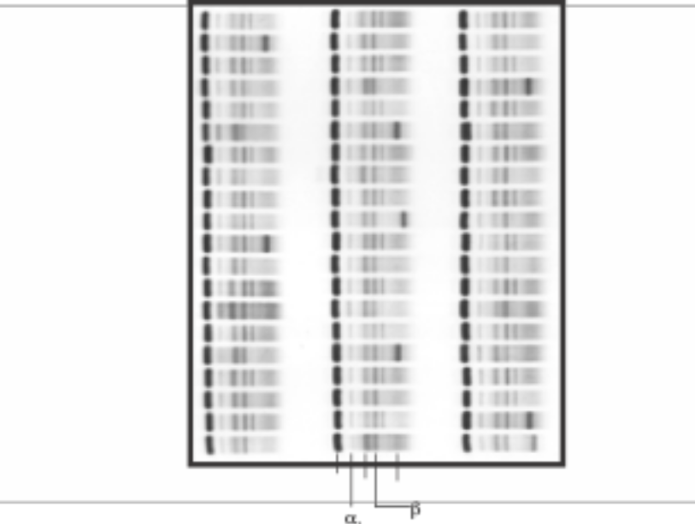
Figure 1: A SPIFE Split Beta SPE-60 Gel showing relative position of the bands.

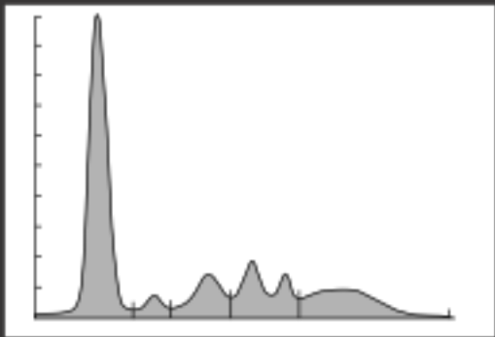
Figure 2: A scan of a SPIFE Split Beta SPE pattern.
Calculations of the Unknown
The SPIFE Nexus scanner will automatically calculate and print the relative percent and the absolute value of each band when the total protein is entered. Refer to the SPIFE Nexus and QuickScan Touch Plus Operator’s Manuals provided with the instrument.
INTERPRETATION OF RESULTS^{5,6}
Results on normal individuals will cover age and sex-related variations and day-to-day biologic variations. Disease states in which abnormal patterns are observed include inflammatory response, rheumatic disease, liver diseases, protein-loss disorders, plasma cell dyscrasias, infectious disorders, renal disorders, pregnancy, and genetic deficiencies. Patients with high levels of IgG4 can produce a relatively restricted band cathodic in the beta gamma region or beta gamma bridging.⁷ Proteins migrating in the alpha₂ and beta region may show slight variation in migration under a variety of circumstances.⁸
Further Testing Required
The serum or urine protein electropherogram, or densitometric tracing, should be evaluated for abnormalities. If abnormalities are observed, appropriate follow-up studies should be initiated.⁹ Not all clinically significant monoclonal gammopathies will display a distinct band detectable by protein electrophoresis.¹⁰ Further studies may be indicated based on clinical context. These may include immunofixation, quantitation of immunoglobulins, bone marrow examination and other appropriate tests.

LIMITATIONS
1. Since all electrophoretic procedures are nonlinear, it is critical to fill the wells with the recommended volume of serum or urine to obtain optimal resolution and reproducible results. Noncompliance with the recommended procedure may affect the results.
2. Therapeutic monoclonal antibodies may be used in the treatment of multiple myeloma as well as various other malignancies or medical conditions. If present in sufficient concentration, these agents may be indistinguishable from a pathologic monoclonal protein on serum protein electrophoresis.^{11,12}
3. Use of plasma will cause a fibrinogen band to appear as a distinct narrow band between the beta and gamma fractions. A fibrinogen band may also be present in patients on heparin therapy.
4. Hemolyzed samples should be avoided as the changes in hemoglobin-haptoglobin may affect the alpha₂ and beta migration.^{13,14}
5. The mobility of beta lipoprotein (low density lipoprotein) can vary considerably and may migrate under normal conditions anywhere between the alpha₂ and beta region. Beta lipoproteins can be recognized by their characteristic appearance as a thin, irregular line, regardless of its migration location.
6. An artifact may be present at the point of application, particularly with the use of frozen samples, older samples, or samples containing debris.¹³ An application artifact may appear as fine clear line (negative space) that may be visible to a faint degree across the entire gel in the beta region. This can on occasion cause the edge of a normal blush to appear slightly blunted.
SPECIFIC PERFORMANCE CHARACTERISTICS
Reproducibility was assessed over a 5 day period. Normal and abnormal serum controls were tested on two gels per day on each of three SPIFE Nexus instruments. Three hundred sixty determinations per protein fraction in total were collected for the normal and abnormal serum protein controls respectively.
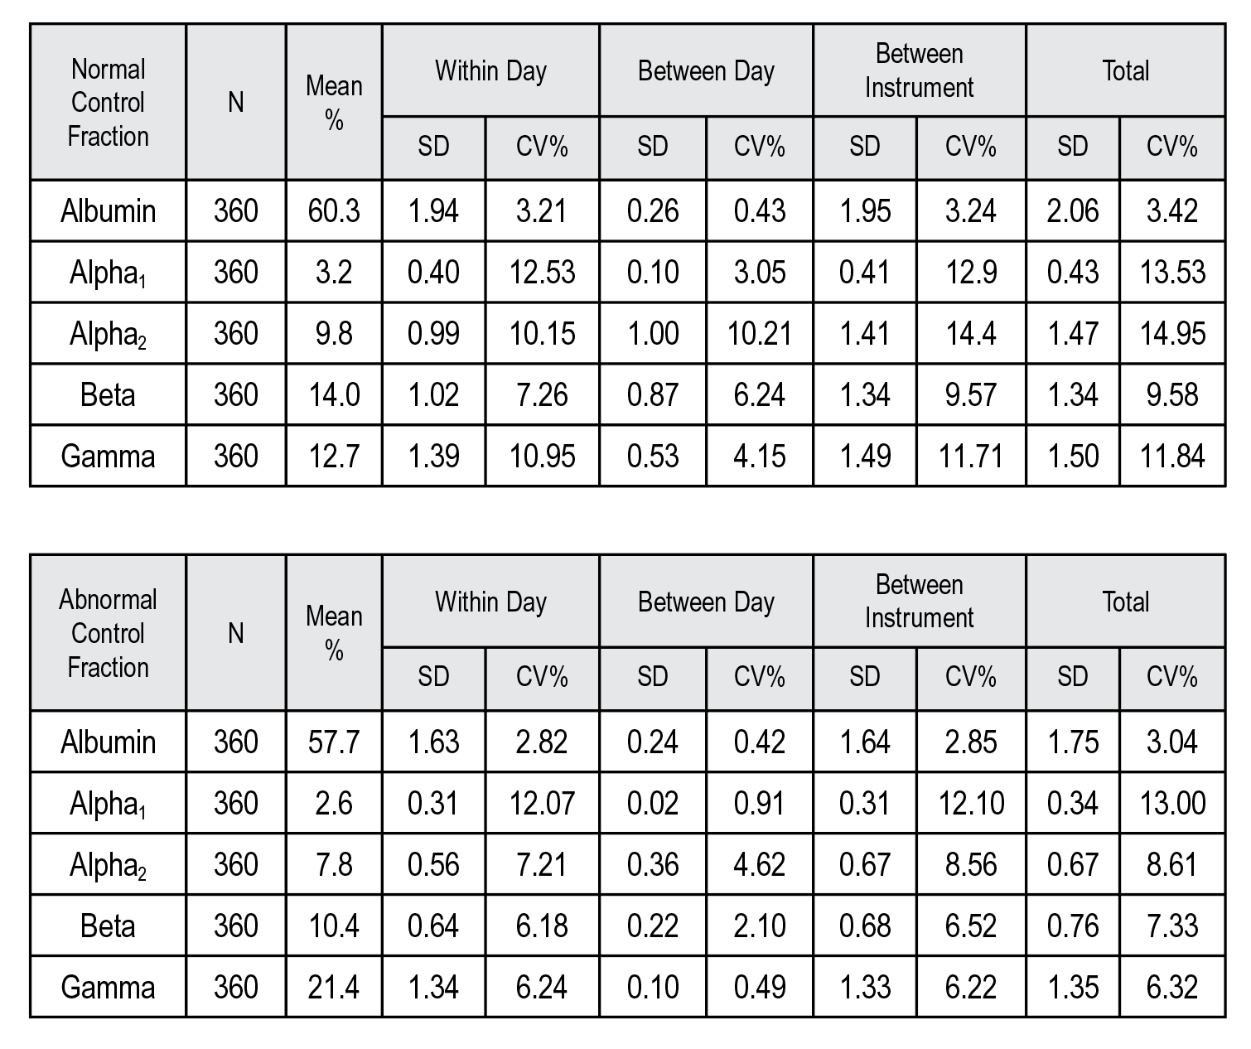

SENSITIVITY
A pathological serum sample with a monoclonal protein at 1.76 g/dL (1760 mg/dL) was serially diluted and the dilutions electrophoresed on the SPIFE Split Beta SPE gel on the SPIFE Nexus. After visual inspection and densitometric analysis of the gel, the lowest detectable concentration of a monoclonal protein was between 0.14 and 0.28 g/L (14 and 28 mg/dL).
Serial dilutions of a pathological urine sample containing a monoclonal were analyzed on the SPIFE Nexus using template application on the SPIFE Split Beta SPE gel. The sensitivity was determined to be between 0.15 and 0.30 g/L (15 and 30 mg/dL) for a single band.
NOTE: The migration position of the monoclonal protein and the presence of a polyclonal background in the gamma zone may affect the detection limit.
CORRELATION
Normal and abnormal serum samples were analyzed using the SPIFE Touch Split Beta SPE system and the SPIFE Nexus Split Beta SPE system. Deming regression with 95% confidence intervals and Pearson correlation coefficient are presented below.
n = 30
Slope: 1.046 (1.026 to 1.066)
Intercept: -0.93 (-1.48 to -0.38)
R = 0.99

BIBLIOGRAPHY
1. Alper CA. Plasma protein measurements as a diagnostic aid. New England Journal of Medicine. 1974;291(6):287-290.
2. Tiselius A. A New Apparatus for Electrophoretic Analysis of Colloidal Mixtures. Transactions of the Faraday Society. 1937;33:524.
3. Ritzmann SE, Daniels JC. Diagnostic Proteinology: Separation and Characterization of Proteins, Qualitative and Quantitative Assays. In: Laboratory Medicine. Vol 1. Hagerstown (MD): Harper and Row, Inc.; 1979.
4. Tietz NW, ed. In: Textbook of Clinical Chemistry. Philadelphia (PA): WB Saunders Company; 1986:579-582.
5. Ritzmann SE, ed. Protein Abnormalities, Volume 1. Physiology of Immunoglobulins: Diagnostic and Clinical Aspects. New York (NY): Allen R. Liss; 1982.
6. Keren DF. Protein Electrophoresis in Clinical Diagnosis. London: Edward Arnold; 2003.
7. Chen LYC, Mattman A, Seidman MA, Carruthers MN. IgG4-related disease: What a hematologist needs to know. Haematologica. 2019;104(3):444-455.
8. Hrkal Z, Kuzelová K, Muller-Eberhard U, Stern R. Hyaluronan-binding properties of human serum hemopexin. FEBS Letters. 1996;383(1-2):72-74.
9. Lakshminarayanan R, Li Y, Janatpour K, Beckett L, Jialal I. Detection by immunofixation of M proteins in hypogammaglobulinemic patients with normal serum protein electrophoresis results. American Journal of Clinical Pathology. 2007;127(5):746-751.
10. Kyle RA, Gertz MA, Witzig TE, et al. Review of 1027 patients with newly diagnosed multiple myeloma. Mayo Clinic Proceedings. 2003;78(1):21-33.
11. Mills JR, Murray DL. Identification of friend or Foe: The Laboratory Challenge of Differentiating M-proteins from Monoclonal Antibody Therapies. The Journal of Applied Laboratory Medicine. 2017;1(4):421-431.
12. Keren DF. Therapeutic Complications: A Caveat for M-protein detection. The Journal of Applied Laboratory Medicine. 2017;1(4):342-345.
13. McCudden CR, Jacobs JFM, Keren D, Caillon H, Dejoie T, Andersen K. Recognition and management of common, rare, and novel serum protein electrophoresis and immunofixation interferences. Clinical Biochemistry. 2018;51:72-79.
14. Strobel SL. The incidence and significance of pseudoparaproteins in a community hospital. Ann Clin Lab Sci. 2000;30(3):289-294.

For Sales, Technical and Order Information and Service Assistance, call 800-231-5663 toll free.
Helena Laboratories warrants its products to meet our published specifications and to be free from defects in materials and workmanship. Helena’s liability under this contract or otherwise shall be limited to replacement or refund of any amount not to exceed the purchase price attributable to the goods as to which such claim is made. These alternatives shall be buyer’s exclusive remedies.
In no case will Helena Laboratories be liable for consequential damages even if Helena has been advised as to the possibility of such damages.
The foregoing warranties are in lieu of all warranties expressed or implied including, but not limited to, the implied warranties of merchantability and fitness for a particular purpose.

© 2023-2026 Helena Laboratories, Corp.

Pro. 85
5/26(5)



