PLEASE READ!!

HELENA LABORATORIES
PROCEDURE DOWNLOAD END USER AGREEMENT

In response to customer requests, Helena is pleased to provide the text for procedural package inserts in a digital format editable for your use. The text for the procedure you requested begins on page three of this document. Helena procedures contain the content outlined in the NCCLS (GP2-A#) format, except in the order sequence required by FDA regulations. As the NCCLS format is a guideline, you may retain these procedures as developed by the manufacturer (adding your title/authorization page) or manipulate the text file to produce your own document, matching the NCCLS section order exactly, if preferred.

We also provide the procedure in an Adobe Acrobat PDF format for download at www.helena.com as a “MASTER” file copy. Below are the specifications and requirements for using these digital files. Following the specifications is the procedure major heading sequence as given in the FDA style. Where there is a difference in order, or other notation in the outline, this will be indicated in braces { }.

WHAT YOU NEED TO KNOW:

1) These files represent the most current revision level to date. Your current product inventory could contain a previous revision level of this procedure.

2) The Microsoft Word document provides the text only from the master procedure, in a single-column format.

- It may not contain any illustrations, graphics or captions that may be part of the master procedure included in the kit.

- The master procedure may have contained special formatting characters, such as subscripts, superscripts, degree symbols, mean symbols and Greek characters such as alpha, beta, gamma, etc. These symbols may or may not display properly on your desktop.

- The master procedures may also contain columns of tabbed data. Tab settings may or may not be displayed properly on your desktop.

3) The Adobe Acrobat PDF file provides a snapshot of the master procedure in a printable 8.5 x 11” format. It is provided to serve as a reference for accuracy.

4) By downloading this procedure, your institution is assuming responsibility for modification and usage.
HELENA LABORATORIES
PROCEDURE DOWNLOAD END USER AGREEMENT

HELENA LABORATORIES LABELING – Style/Format Outline

- PRODUCT {Test} NAME
- INTENDED USE and TEST TYPE (qualitative or qualitative)
- SUMMARY AND EXPLANATION
- PRINCIPLES OF THE PROCEDURE
{NCCLS lists SAMPLE COLLECTION/HANDLING next}
- REAGENTS (name/concentration; warnings/precautions; preparation; storage; environment; Purification/treatment; indications of instability)
- INSTRUMENTS required – Refer to Operator Manual (... for equipment for; use or function; Installation; Principles of operation; performance; Operating Instructions; Calibration* {*is next in order for NCCLS – also listed in “PROCEDURE”}’ precautions/limitations/hazards; Service and maintenance information
- SAMPLE COLLECTION/HANDLING
- PROCEDURE
{NCCLS lists QUALITY CONTROL (QC) next}
9) RESULTS (calculations, as applicable; etc.)
10) LIMITATIONS/NOTES/INTERFERENCES
11) EXPECTED VALUES
12) PERFORMANCE CHARACTERISTCS
13) BIBLIOGRAPHY (of pertinent references)
14) NAME AND PLACE OF BUSINESS OF MANUFACTURER
15) DATE OF ISSUANCE OF LABELING (instructions)

For Sales, Technical and Order Information, and Service Assistance,
call Helena Laboratories toll free at 1-800-231-5663.

Form 364
Helena Laboratories
1/2006 (Rev 3)

Cat. No. 3340, 3341, 3342, 3343 SPIFE® 3000
Lipoprotein Procedure
The SPIFE Lipoprotein Electrophoresis method is intended for the separation and quantitation of plasma lipoproteins by agarose gel electrophoresis using the SPIFE 2000 or 3000 system.
SUMMARY
Since Fredrickson and Lees proposed a system for phenotyping hyperlipoproteinemia in 1965¹, the concept of coronary artery disease detection and prevention utilizing lipoprotein electrophoresis has become relatively common.
Epidemiologic studies have related dietary intake of fats, especially cholesterol and blood levels of the lipids to the incidence of atherosclerosis, the major manifestations of which are cardiovascular disease and stroke. Ischemic heart disease has also been related to hypercholesterolemia.^{2, 3}
The need for accurate determination of lipoprotein phenotypes resulted from the recognition that hyperlipoproteinemia is symptomatic of a group of disorders dissimilar in clinical features, prognosis and responsiveness to treatment. Since treatments of the disorders vary with the different phenotypes, it is absolutely necessary that the correct phenotype be established before therapy is begun.⁴ In the classification system proposed by Fredrickson and Lees, only types II, III and IV have a proven relationship to atherosclerosis.
Plasma lipids do not circulate freely in the plasma, but are transported bound to protein and can thus be classified as lipoproteins. These various fractions are made of different combinations of protein, cholesterol, glycerides, cholesterol esters, phosphatides and free fatty acids.⁵
Several techniques have been employed to separate the plasma lipoproteins, including ultracentrifugation, thin layer chromatography, immunological techniques, and electrophoresis. Electrophoresis and ultracentrifugation are two of the most widely used methods and each has given rise to its own terminology. Table 1 shows the correlation of these classifications and the relative lipid and protein composition of each fraction.
Table 1: Classification and Composition of Lipoprotein Fractions
Classification according to Composition - % in each Fraction
Electrophoretic Ultra- Phospho-
Mobility Centrifuge Protein Glyceride Cholesterol lipids
Chylomicrons 2% 98%
Beta LDL* 21% 12% 45% 22%
Pre-Beta VLDL* 10% 55% 13% 22%
Alpha HDL* 50% 6% 18% 26%
*Non standard abbreviations: LDL (low density lipoprotein), VLDL (very low density lipoprotein), HDL (high density lipoprotein).

Various exceptions to the above classifications inevitably exist. One of these is the “sinking pre-beta,” which is pre-beta migrating material that “sinks” in the ultracentrifuge, along with the LDL (beta migrating) fraction.⁶ This is the Lp(a) lipoprotein reported by Dahlen.⁷ It is considered a variant found in 20% of the population.¹⁵ If a fourth band appears between pre-beta and alpha, it is Lp(a) and should be quantitated with pre-beta.
Another exception is the “floating beta,” which is beta migrating material “floating” in the ultracentrifuge with the VLDL. The abnormal lipoprotein appears in Type III hyperlipoproteinemias.
Various types of support media have been used for the electrophoretic separation of lipoproteins. When Fredrickson originally devised the classification system, he used paper electrophoresis.^{1, 8} More recently agarose gel, starch block, and polyacrylamide gel have been used.^{5, 7}
PRINCIPLE
The specimen is applied to an agarose gel, the lipoprotein fractions are separated by electrophoresis and stained with Fat Red 7B. The stained bands may be visually inspected for qualitative results or may be quantitated in a scanning densitometer using a 525 nm filter or in a QuickScan Touch/2000.
REAGENTS
1. SPIFE Lipoprotein Gel
Ingredients: Each gel contains agarose in a sodium barbital buffer with EDTA, guanidine hydrochloride, and magnesium chloride. Sodium azide and other preservatives have been added.
WARNING: FOR IN-VITRO DIAGNOSTIC USE ONLY. The gel contains barbital which, in sufficient quantities, can be toxic. To prevent the formation of toxic vapors, this product should not be mixed with acidic solutions. When discarding this reagent always flush sink with copious quantities of water. This will prevent the formation of metallic azides which, when highly concentrated in metal plumbing, are potentially explosive. In addition to purging pipes with water, plumbing should occasionally be decontaminated with 10% NaOH.
Preparation for Use: The gels are ready for use as packaged.
Storage and Stability: The gels should be stored horizontally at room temperature (15 to 30°C), in the protective packaging, and are stable until the expiration date indicated on the package. DO NOT REFRIGERATE OR FREEZE THE GELS.
Signs of Deterioration: Any of the following conditions may indicate deterioration of the gel: (1) crystalline appearance indicating the agarose has been frozen, (2) cracking and peeling indicating drying of the agarose, (3) bacterial growth indicating contamination, (4) thinning of gel blocks.
2. Lipoprotein Stain
Ingredients: When reconstituted as directed, the stain contains 0.1% (w/v) Fat Red 7B in 95% methanol.
WARNING: FOR IN-VITRO DIAGNOSTIC USE ONLY.
Preparation of Stock Stain Solution: Dissolve the stain (entire contents of vial) with 1 L of 95% methanol. Stir overnight, allow stock solution to stand for 1 day and filter before use.
Storage and Stability: The stain should be stored at 15 to 30°C and is stable until the expiration date indicated on the package. The diluted stain is stable for two months stored at 15 to 30°C. The filtered stain should be stored in a screw top container at 15 to 30°C.
Signs of Deterioration: The diluted stain should be a homogeneous mixture free of precipitate.
INSTRUMENTS
A SPIFE 3000 must be used to electrophorese the gel. The gel can be scanned on a densitometer such as the QuickScanTouch/2000 (Cat. No. 1690/1660). Refer to the appropriate Operator’s Manual for detailed operating instructions.
SPECIMEN COLLECTION AND HANDLING
Specimen: Serum or plasma from samples collected in EDTA may be used. Do not use plasma collected in heparin. Fresh serum is the specimen of choice.
Patient Preparation: For the most accurate phenotyping of lipoprotein patterns, the following precautions should be observed before sampling.⁹
1. Discontinue all drugs, if possible, for 3-4 weeks.
2. The patient should be maintaining a standard weight and on a diet considered normal for at least one week.
3. Wait 4-8 weeks after a myocardial infarction or similar traumatic episode.
4. The patient should be fasting for a 12-14 hour period. Chylomicrons normally appear in the blood 2-10 hours after a meal; therefore, a 12-14 hour fast is necessary to define hyperlipoproteinemia.
Interfering Substances: Heparin therapy causes activation of lipoprotein lipase, which increases the relative migration rates of the fractions, especially the beta lipoprotein.¹⁰
Serum Storage: For best results, fresh serum should be used. Storage at 2 to 8°C for no more than 5 days yields satisfactory results. Prolonged storage increases the migration rate of the pre-beta fraction. Do not freeze.¹¹
PROCEDURE
Materials Provided: The following materials needed for the procedure are contained in the SPIFE Lipoprotein Kits.
Sample Test Size Cat. No.
80 sample 3340
60 sample 3341
40 sample 3342
20 sample 3343

SPIFE Lipoprotein Gels (10)
Lipoprotein Stain (1 vial)
REP Blotter C (10)
Electrode Blotter (20)
Applicator Blade Assembly - 20 Sample
Materials provided, but not contained in the kit:
Item Cat. No.
SPIFE 3000 1088
QuickScan Touch 1690
QuickScan 2000 1660
Lipotrol 5069
REP Prep 3100
REP Gel Staining Dish (10) 1362
Gel Block Remover 1115
SPIFE Disposable Sample Cups (Deep Well) 3360
SPIFE 20-80 Dispo Cup Tray 3364
SPIFE Disposable Stainless Steel Electrodes 3388
Materials Needed but not Supplied:
Methanol
Destaining Solution: Mix 75 mL methanol with 25 mL deionized water.
STEP-BY-STEP METHOD
NOTE: If a SPIFE procedure requiring a stain has been run prior to running the Lipoprotein gels, the stainer unit must be cleaned/washed before drying the gel. The new software version 1.20 has an automatic wash cycle prompted by initiation of a test which does not use the stainer unit for staining when the previous test did use the stainer for staining. To avoid delays after staining, this wash cycle should be initiated at least seven (7) minutes prior to the end of staining. To verify the status, press the TEST SELECT/CONTINUE button on the stainer until the appropriate test is selected. Place an empty Gel Holder in the stainer unit. If cleaning is required, the “Wash 1” prompt will appear, followed by “Plate out, Holder in” prompts. Press “Continue” to begin the stainer wash. The cleaning process will complete automatically in about 7 minutes. The unit is then ready to dry the gel.
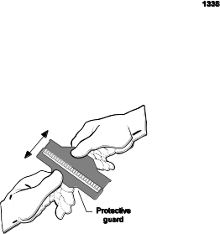
I. Sample Preparation
1. If testing 61-80 samples, remove four disposable Applicator Blade Assemblies from the packaging. If testing fewer samples, remove the appropriate number of Applicator Assemblies from the packaging. Remove the protective guards from the blades by gently bending the protective piece back and forth until it breaks free.
2. Place the four Applicator Blades into the vertical slots in the Applicator Assembly identified as 2, 6, 11 and 15. If using fewer Applicator Blades, place them into any of the four slots noted above. Please note that the blade assembly will only fit into the slots one way; do not try to force the blade assembly into the slots.
3. Slide the appropriate number of cup strips into the slots in the Cup Tray.
4. Pipette 75-80 µL of patient serum or control into each well of the Disposable Cups. If testing less than 61 samples, pipette samples into the row of cups that corresponds with Applicator Blade placement. Cover the tray until ready to use.
II. Gel Preparation
1. Remove the gel from the protective packaging and discard overlay. Using a REP Blotter C, gently blot the entire gel using slight fingertip pressure on the blotter. Remove the blotter.
2. Dispense approximately 2 mL of REP Prep onto the left side of the electrophoresis chamber.
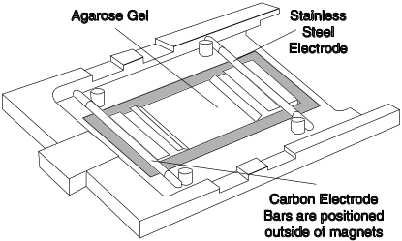
3. Place the left edge of the gel over the REP Prep aligning the round hole on the left pin of the chamber. Gently lay the gel down on the REP Prep, starting from the left side and ending on the right side, fitting the obround hole over the right pin. Use lint-free tissue to wipe around the edges of the plastic gel backing, especially next to electrode posts, to remove excess REP Prep. Make sure no bubbles remain under the gel.
4. Thoroughly wash the electrodes with deionized water before and after each use. Wipe the carbon electrodes with a lint-free tissue. The Disposable Electrode must be patted dry because of the rough surface. Ensure that the endcaps are screwed on tightly. The Disposable Electrode must be replaced after use on 50 gels. Unscrew the endcaps from the old electrode and screw them tightly onto the new electrode.
5. Place a carbon electrode on the outside ledge of the cathode gel block (left side of the gel) outside the magnetic posts.
6. Place a Disposable Stainless Steel Electrode on the outside ledge of the anode gel block (right side of the gel) outside the magnetic posts.
7. Place an Electrode Blotter directly above and below the cathode end of the gel block. Slide the blotters under the ends of the carbon electrode so that they touch the gel block ends. Close the chamber lid.
8. Press the TEST SELECT/CONTINUE button located on the Electrophoresis and Stainer sides of the instrument until LIPO option appears on the display.
III. Electrophoresis
Using the instructions provided in the Operator’s Manual, set up the pa-
rameters as follows for the SPIFE 3000:

Electrophoresis Unit
1) No Prompt
Load Sample 1 00:30 20°C SPD6
2) No Prompt
Apply Sample 1 1:00 20°C SPD6 LOC1
3) No Prompt
Electrophoresis 20:00 16°C 400 Volt 150mA
4) Remove gel blocks (continue)
Dry 1 8:00 54°C
5) No prompt
END OF TEST
Stainer Unit
1) No Prompt
Dry 1 10:00 70°C
2) No Prompt
END OF TEST
1. Place the Cup Tray with samples on the SPIFE 3000. Align the holes in the tray with the pins on the instrument.
2. With LIPO on the display, press the START/STOP button. An option to either begin the test or skip the operation will be presented. Press START/STOP to begin. The SPIFE 3000 will apply the samples, electrophorese and beep when completed.
3. Open the chamber lid, remove and dispose of Electrode Blotters. Dispose of blades as biohazardous waste.
4. Using a Gel Block Remover, completely remove the two gel blocks from the gel and discard the gel blocks. Place an electrode on each end of the gel during the drying process to prevent curling. Close the chamber lid.
5. Press the TEST SELECT/CONTINUE button to dry the gel.
IV. Visualization of the Lipoprotein Bands
1. Preparation of Staining Solutions
a. Stock Stain Solution: Mix the Lipoprotein Stain in 1 L methanol. Allow to stir overnight and stand for one day. Filter before use. Store at 15 to 30°C.
b. Working Stain Solution: Approximately 5 minutes before use, prepare a working solution of Lipoprotein Stain by adding 5 mL deionized water to 25 mL of stock Lipoprotein stain solution. For best results, add the water to the stain in a dropwise manner while swirling the solution.
c. Destaining Solution: Mix 75 mL methanol with 25 mL deionized water. Mix thoroughly.
2. Recommended Staining Procedure
a. Place the gel in the REP Gel Staining Dish, agarose side up. Carefully pour 30 mL of the Working Stain Solution directly on the agarose. Wait 4 minutes. Pour off the stain.
b. Place the gel in Destain Solution for 10 to 20 seconds. Remove excess stain from the sample area using a gloved finger to gently and evenly wipe the gel surface. Pour off the Destain.
c. Destain the gel again for 10 to 20 seconds. Pour off the Destain Solution.
d. A brief final water wash may be necessary if trace amounts of background stain remain on the gel. Excessive destaining may cause light or faded bands and/or non-quantitation of control.
3. Drying the Gel
a. Attach the gel to the SPIFE Gel holder by placing the round hole in the gel mylar over the left pin on the holder and the obround hole over the right pin on the holder.
b. Place the Gel Holder with the attached gel facing backwards into the stainer chamber.
c. With LIPO on the display, press the START/STOP button. An option to either begin the test or skip the operation will be presented. Press START/STOP to begin. The instrument will dry the gel.
d. When the gel has completed the process, the instrument will beep. Remove the Gel Holder from the stainer and you can scan the bands.
V. Evaluation and Quantitation
1. Qualitative evaluation: The SPIFE Lipoprotein Gel may be visually inspected for the presence of bands.
2. Quantitative evaluation: Scan the Lipoprotein Gel in the QuickScan Touch/2000 using slit 5.

Stability of End Product: Gels to be scanned for the quantitative determination of the bands must be scanned as soon as possible. Gels to be visually inspected for qualitative evaluation only may be kept an indefinite period of time after being processed.
Calibration: A calibration curve is not necessary because relative concentration of the bands is the only parameter determined.
Quality Control:
Lipotrol (Cat. No. 5069) can be used to verify all phases of the procedure and should be used on each gel run. The control should be used as a marker for location of the lipid bands and may also be quantitated to verify the accuracy of quantitations. Refer to the package insert provided with each control for assay values. Additional QC controls may be required for federal, state or local regulations.
REFERENCE VALUES
Reference range studies were established using 37 male and female adults with a total cholesterol of ≤ 200 mg/dL.
Lipoprotein Fraction % of Total Lipoprotein
Alpha 12.6 - 46.6
Pre-Beta 0 - 57.1
Beta 21.7 - 67.7
Chylomicrons < 1.0
Any quantitation of Lp(a) must be added to pre-beta for an accurate total pre-beta.
These values are intended as guidelines. Each laboratory should establish its own normal range study because of population differences in various regions.
RESULTS
The Alpha-lipoprotein (HDL) band is the fastest moving fraction and is located closest to the anode. The Beta-lipoprotein (LDL) band is usually the most prominent fraction and is near the origin, migrating cathodic to the point of application. The pre-Beta lipoprotein (VLDL) band migrates between Alpha and Beta lipoprotein. The mobility of the pre-Beta fraction varies with the degree of resolution obtained, the type of pre-Beta present, and the percent of Beta present. Sometimes pre-Beta will be seen as a smear just ahead of the Beta fraction. Other times it may be split into two or more fractions or may be lacking altogether. The integrity of the pre-Beta fraction decreases with sample age. Chylomicrons, when present, stay at the point of application.
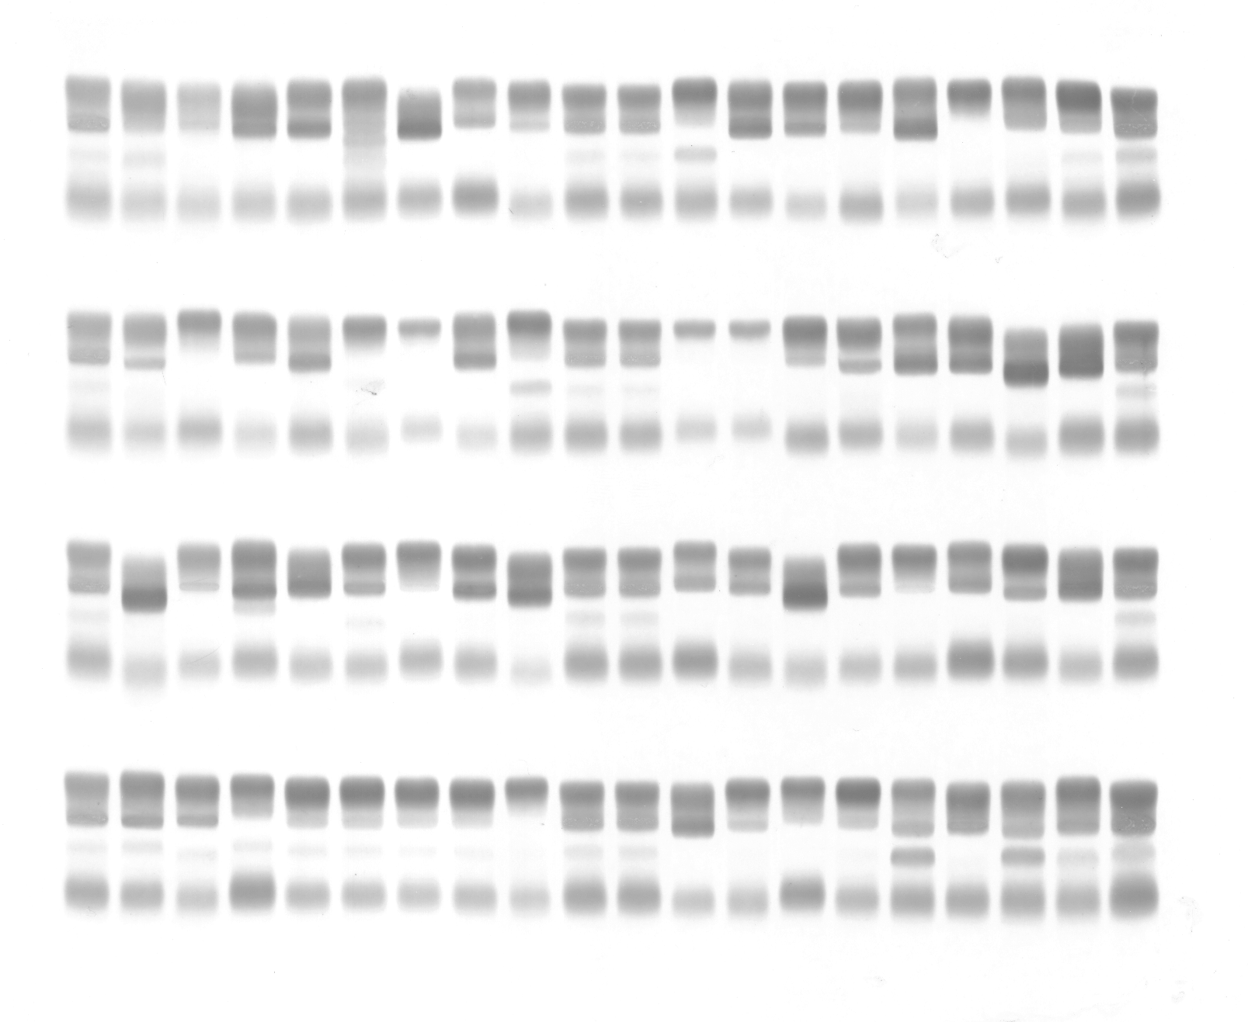

Figure 1: A SPIFE Lipoprotein gel illustrating the band positions.
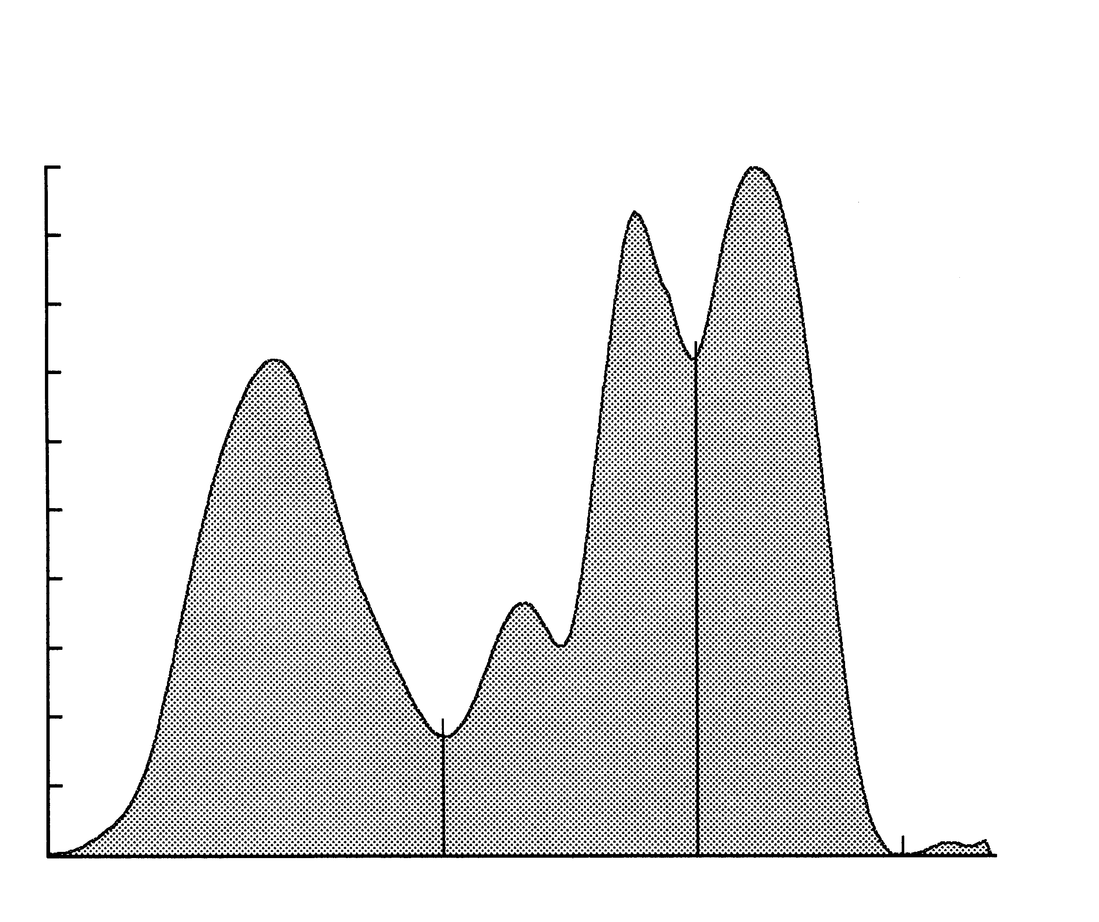

Figure 2: A scan of a SPIFE Lipoprotein pattern with an Lp(a) band.
Calculations of the Unknown: Figure 2 shows a typical lipoprotein scan produced by a QuickScan 2000. The relative percent of each band is computed and printed automatically by the densitometer. The calculated percent of the Lp(a) band must be added to the percent of the pre-Beta band for a total pre-Beta value.
Calculating the mg/dL of total lipids from the relative percent values obtained is not recommended. (See LIMITATIONS.)

INTERPRETATION OF RESULTS
Lipoprotein Phenotyping Using the SPIFE Lipoprotein Electrophoresis Method:
Normal Pattern - A normal fasting serum can be defined as a clear serum with negligible chylomicrons and normal cholesterol and triglyceride levels. On electrophoresis, the Beta lipoprotein appears as the major fraction with the pre-Beta lipoprotein faint or absent and the Alpha band definite but less intense than the Beta. If a fourth band appears between pre-beta and alpha, it is Lp(a) and should be quantitated with the pre-Beta band.
Abnormal Patterns - A patient must have an elevated cholesterol or triglyceride to have hyperlipoproteinemia. The elevation must be determined to be primary or secondary to metabolic disorders such as hypothyroidism, obstructive jaundice, nephrotic syndrome, dysproteinemias, or poorly controlled insulinopenic diabetes mellitus. Primary lipidemia arises from genetically determined factors or environmental factors of unknown mechanism such as diet, alcohol intake, and drugs, especially estrogen or steroid hormones.¹⁴ Also considered primary are those lipoproteinemias associated with ketosis-resistant diabetes, pancreatitis, and obesity. Diabetes mellitus and pancreatitis can be confusing, for it is often difficult to tell whether the hyperlipoproteinemia or the disease is the causative factor.
LIMITATIONS
Limiting Factors: Fat Red 7B, as well as the Sudan black stains, has a much greater affinity for triglycerides and cholesterol esters than it has for free cholesterol and phospholipids. Bands seen after staining with these dyes do not reflect a true quantitation of the total plasma lipids.¹² For this reason it is not recommended that relative percentages of lipoprotein bands be used to calculate the total lipid content in each fraction from a total plasma lipid value. Since most laboratories routinely offer total cholesterol and triglyceride levels, this information is unnecessary.
Interfering Factors: Specimens collected in heparin should not be used since heparin alters the migration patterns of the lipoprotein fractions.
Further Testing Required: Since the lipid composition of each lipoprotein fraction is variable, it is essential to determine total cholesterol and triglyceride levels before attempting to classify a pattern.^{8, 9} When it becomes necessary to diagnose or rule out a Type III hyperlipoproteinemia, a more definitive quantitation of the lipoproteins such as ultracentrifugation⁴ or electrophoresis on polyacrylamide gel¹³ is essential.
PRIMARY LIPOPROTEINEMIAS
The Fredrickson Classification
Type I: Hyperchylomicronemia
Criteria: Chylomicrons present, pre-Beta normal or only slightly elevated. Alpha and Beta decreased, often markedly so. Standing plasma with marked creamy layer.
Confirmation: A measurement of post-heparin lipolytic activity (PHLA) and the demonstration of severe intolerance to exogenous fat. The condition is rare and always familial. There has been no correlation to vascular disease. It is thought to be due to a genetic deficiency of lipoprotein lipase.⁸
Type II: Hyperbetalipoproteinemia
Criteria: Increased total cholesterol due to an increased Beta-lipoprotein cholesterol. Alpha cholesterol usually normal or low.
Type IIa: normal pre-Beta, normal triglycerides, plasma clear.
Type IIb: increased pre-Beta and triglycerides, plasma clear to slightly turbid with no creamy layer.
This is one of the most common familial forms of hyperproteinemias.
Secondary causes: Myxedema, myelomas, macroglobulinemias, nephrosis, liver disease, excesses in dietary cholesterol and saturated fats.
Type III: “Broad Beta” - Abnormal Lipoprotein
Criteria: Presence of triglyceride burdened lipoprotein of abnormal composition and density. Cholesterol and triglyceride elevated. The abnormal material has broad beta electrophoretic mobility but separates with VLDL in the ultracentrifuge. Plasma turbid to cloudy. The abnormal lipoprotein is also known as “floating Beta”. The condition is rare.
Confirmation: Polyacrylamide gel electrophoresis¹³ or ultracentrifuge studies to demonstrate the abnormal lipoprotein.
Type IV: Carbohydrate Induced Endogenous Hypertriglyceridemia
Criteria: Increased pre-Beta, increased triglycerides, normal or slightly increased total cholesterol. Alpha and Beta lipoprotein usually normal. (An increased pre-Beta with normal triglyceride level is seen with the normal variant “sinking pre-Beta.” Such samples do not belong to Type IV.)
Secondary causes: Nephrotic syndrome, diabetes mellitus, pancreatitis, glycogen storage disease, and other acute metabolism changes where mobilization of free fatty acids is increased. Endogenous triglycerides are very sensitive to alcohol intake, emotional stress, diet and changes in weight. Little effect is seen with exogenous triglyceride intake. Ninety percent of persons with familial Type IV have an abnormal glucose tolerance. Probably the most common type of hyperlipoproteinemia reflecting an imbalance in synthesis and clearance of endogenous triglycerides.
Type V: Mixed Triglyceridemia (carbohydrate and fat included)
Criteria: Increased exogenous and endogenous triglycerides, cholesterol increased, chylomicrons present, pre-Beta increased, Beta normal to slightly increased.
Secondary causes: Nephrosis, myxedema, diabetic acidosis, alcoholism, pancreatitis, glycogen storage disease and other acute metabolic processes.⁴
Note: Only Types II, III, and IV have been correlated to vascular disease.
THE ALPHA LIPOPROTEINS IN DISEASE
Marked increases in the Alpha lipoproteins are seen in obstructive liver disease and cirrhosis. Marked decreases are seen in parenchymal liver disease. Tangier’s disease is a rare genetic disorder characterized by the total absence of normal Alpha lipoproteins. Heterozygotes exhibit decreased levels of Alpha lipoproteins.⁸ It should be noted that hyperestrogenemia (pregnancy or oral contraceptive use) may cause moderate elevations in the Alpha lipoproteins.¹²
DECREASES IN THE BETA LIPOPROTEINS
Abetalipoproteinemia is a primary inherited defect characterized by severe deficiency of all lipoproteins of density less than 1.063 (all but the Alpha lipoproteins). It is accompanied by numerous clinical symptoms and life expectancy is limited. A few cases of familial hypobetalipoproteinemia have been reported. There is some evidence that the mutation is different from that producing abetalipoproteinemia.
LIPOPROTEIN-X
Lipoprotein-X is an abnormal lipoprotein often seen in patients with liver disease. It consists of unesterified (free) cholesterol, phospholipids and protein. It migrates slower than LDL. Because of its particular lipid contents, it stains poorly or not at all with the usual lipid stains and so is not usually detected by standard lipoprotein electrophoretic methods.
PERFORMANCE CHARACTERISTICS
PRECISION
Within Run precision was evaluated by analyzing one sample 80 times on one gel. N = 80
Lipoprotein Fraction Mean % SD CV
Alpha 25.2 0.8 3.1%
Pre-Beta 23.7 0.5 2.1%
Beta 51.1 0.9 1.7%

Between Run: Normal samples were run 80 times each on 5 gels with the following results. N = 400
Lipoprotein Fraction Mean % SD CV
Alpha 24.1 2.1 8.5%
Pre-Beta 22.4 1.6 7.4%
Beta 53.5 3.5 6.5%
CORRELATION
Correlation studies were performed on 64 normal and abnormal specimens. The SPIFE Lipoprotein method was compared to the REP Lipo-30 method resulting in the following linear regression:
N = 64 X = REP Lipo-30
Y = 0.936X + 2.136 Y = SPIFE Lipoprotein
r = 0.957
BIBLIOGRAPHY
1. Fredrickson, D.S., and Lees, R.S., A System for Phenotyping Hyperlipoproteinemias, Circulation, 31(3):321-327, 1965.
2. Henry, R.J. Ed., Clinical Diagnosis and Management of Laboratory Methods, 20th Ed. W.B. Saunders Co., New York, 240-245, 2001.
3. Lewis, L.A. and Opplt, J.J. Ed., CRC Handbook of Electrophoresis Vol II Lipoproteins in Disease, CRC Press, Inc., Florida, 63-239, 1980.
4. Levy, R.I. and Fredrickson, D.S., Diagnosis and Management of Hyperlipoproteinemia, Am. J. Card. 22(4):576-583, 1968.
5. Houstmuller, A.J., Agarose-gel Electrophoresis of Lipoproteins: A Clinical Screening Text, Koninklijke Van Gorcum and Comp. The Nederlands, p. 5, 1969.
6. Stonde, N.J. and Levy, R.I., The Hyperlipidemias and Coronary Artery Disease, Disease-a-Month, 1972.
7. Dahlen, Gosta, The Pre-Beta Lipoprotein Phenomenon in Relation to Serum Cholesterol and Triglyceride Levels: The Lp(a) Lipoprotein and Coronary Heart Disease, Umea University Medical Dissertations, Sweden, No. 20, 1974.
8. Fredrickson, D.S., Levy, R.I., Lees, R.S., Fat Transport in Lipoproteins - An Intergrated Approach to Mechanisms and Disorders, N. Eng. Jour. Med., 276:34-42, 94-103, 148-156, 215-226, 273-281, 1967.
9. Fredrickson, D.S., When to Worry about Hyperlipidemia, Consultant, Dec., 1974.
10. Houstmuller, A.J., Heparin Induced Post Beta Lipoprotein, Lancet 7470(II), 976, 1966.
11. Hatch, F.T. and Lees, R.S., Practical Methods for Plasma Lipoprotein Analysis, Advan. Lipid Res. 6:1, 1968.
12. Davidsohn, I. and Henry, J.B., Todd-Sanford: Clinical Diagnosis by Laboratory Methods, 15th ed., p. 638-639, 1974.
13. Masket, B.H., Levy, R.I., and Fredrickson, D.S., The Use of Polyacrylamide Gel Electrophoresis in Differentiating Type III Hyperlipoproteinemia, J. Lab & Clin. Med., 81(5):794-802, 1973.
14. World Health Organization Memorandum: Classification of Hyperlipidemias and Hyperlipoproteinemias, Circulation, 45:501-508, 1972.
15. Lynch, G.J., et al, Routine Lipid Screening by Cholesterol Staining Electrophoresis - Including Lipoprotein(a) Cholesterol (Lp(a)-c), Aust. Jour of Med Sci, 19:123-126, Nov. 1998.

For Sales, Technical and Order Information and Service Assistance, call 800-231-5663 toll free.

Helena Laboratories warrants its products to meet our published specifications and to be free from defects in materials and workmanship. Helena’s liability under this contract or otherwise shall be limited to replacement or refund of any amount not to exceed the purchase price attributable to the goods as to which such claim is made. These alternatives shall be buyer’s exclusive remedies.
In no case will Helena Laboratories be liable for consequential damages even if Helena has been advised as to the possibility of such damages.
The foregoing warranties are in lieu of all warranties expressed or implied including, but not limited to, the implied warranties of merchantability and fitness for a particular purpose.




