PLEASE READ!!

HELENA LABORATORIES
PROCEDURE DOWNLOAD END USER AGREEMENT

In response to customer requests, Helena is pleased to provide the text for procedural package inserts in a digital format editable for your use. The text for the procedure you requested begins on page three of this document. Helena procedures contain the content outlined in the NCCLS (GP2-A#) format, except in the order sequence required by FDA regulations. As the NCCLS format is a guideline, you may retain these procedures as developed by the manufacturer (adding your title/authorization page) or manipulate the text file to produce your own document, matching the NCCLS section order exactly, if preferred.

We also provide the procedure in an Adobe Acrobat PDF format for download at www.helena.com as a “MASTER” file copy. Below are the specifications and requirements for using these digital files. Following the specifications is the procedure major heading sequence as given in the FDA style. Where there is a difference in order, or other notation in the outline, this will be indicated in braces { }.

WHAT YOU NEED TO KNOW:

1) These files represent the most current revision level to date. Your current product inventory could contain a previous revision level of this procedure.

2) The Microsoft Word document provides the text only from the master procedure, in a single-column format.

- It may not contain any illustrations, graphics or captions that may be part of the master procedure included in the kit.

- The master procedure may have contained special formatting characters, such as subscripts, superscripts, degree symbols, mean symbols and Greek characters such as alpha, beta, gamma, etc. These symbols may or may not display properly on your desktop.

- The master procedures may also contain columns of tabbed data. Tab settings may or may not be displayed properly on your desktop.

3) The Adobe Acrobat PDF file provides a snapshot of the master procedure in a printable 8.5 x 11” format. It is provided to serve as a reference for accuracy.

4) By downloading this procedure, your institution is assuming responsibility for modification and usage.
HELENA LABORATORIES
PROCEDURE DOWNLOAD END USER AGREEMENT

HELENA LABORATORIES LABELING – Style/Format Outline

- PRODUCT {Test} NAME
- INTENDED USE and TEST TYPE (qualitative or qualitative)
- SUMMARY AND EXPLANATION
- PRINCIPLES OF THE PROCEDURE
{NCCLS lists SAMPLE COLLECTION/HANDLING next}
- REAGENTS (name/concentration; warnings/precautions; preparation; storage; environment; Purification/treatment; indications of instability)
- INSTRUMENTS required – Refer to Operator Manual (... for equipment for; use or function; Installation; Principles of operation; performance; Operating Instructions; Calibration* {*is next in order for NCCLS – also listed in “PROCEDURE”}’ precautions/limitations/hazards; Service and maintenance information
- SAMPLE COLLECTION/HANDLING
- PROCEDURE
{NCCLS lists QUALITY CONTROL (QC) next}
9) RESULTS (calculations, as applicable; etc.)
10) LIMITATIONS/NOTES/INTERFERENCES
11) EXPECTED VALUES
12) PERFORMANCE CHARACTERISTCS
13) BIBLIOGRAPHY (of pertinent references)
14) NAME AND PLACE OF BUSINESS OF MANUFACTURER
15) DATE OF ISSUANCE OF LABELING (instructions)

For Sales, Technical and Order Information, and Service Assistance,
call Helena Laboratories toll free at 1-800-231-5663.

Form 364
Helena Laboratories
1/2006 (Rev 3)
Helena ColoScreen® iFOBT
Cat. No. 5061, 5062, 5063, 5064
INTENDED USE
The Helena ColoScreen Immunochemical Fecal Occult Blood Test (iFOBT) is an immunochemical device intended for the qualitative detection of Fecal Occult Blood by laboratories or physicians offices. It is useful in determining gastrointestinal (GI) bleeding found in a number of gastrointestinal disorders, such as: diverticulitis, colitis, polyps, and colorectal cancer. This test is recommended for use in: 1) routine physical examinations or when hospital patients are first admitted, 2) hospital monitoring for GI bleeding in patients, and 3) screening for colorectal cancer or gastrointestinal bleeding.
SUMMARY AND EXPLANATION
The American Cancer Society and Centers for Disease Control recommend an occult blood feces test annually after age 50 to aid in the early detection of
colorectal cancer.¹ Three types of assays for FOB testing are commercially available: 1) Guaiac Dye; 2) Hemoporphyrin; and, 3) lmmunochemical.
The Guaiac test is widely available but lacks high accuracy. Guaiac is a naturally occurring phenolic compound that can be oxidized to quinone by hydrogen peroxidases with a detectable color change. The sensitivity and specificity of Guaiac tests are much lower than those of Hemoporphyrin tests and lmmunochemical assays. The low accuracy of the Guaiac Dye method is related to dietary peroxidases, including hemoglobin and myoglobin from meat and uncooked fruits and vegetables. Non-cancerous gastrointestinal tract bleeding and iron intake may also cause false positive results from Guaiac test.²
The Hemoporphyrin test is not affected by dietary peroxidases, but false- positive results can occur in patients with upper gastrointestinal bleeding
disorders such as gastric or duodenal ulcers because porphyrins are not
broken down by stomach acids.²
The Helena immunochemical FOB rapid test is much more sensitive and has been designed to specifically detect low levels of human fecal occult blood. It is highly accurate for human hemoglobin (hHb) compared to the Guaiac and Hemoporphyrin methods. The results of immunochemical FOB rapid tests are not affected by dietary peroxidases, animal blood and ascorbic acid. A Japanese study demonstrated using immunochemical FOB tests reduced mortality by 60%.³
PRINCIPLE OF THE PROCEDURE
This assay is a one-step lateral flow chromatographic immunoassay. The test strip consists of: 1) a burgundy colored conjugate pad containing mouse anti-hHb antibodies conjugated with colloidal gold and 2) a nitrocellulose membrane strip containing a Test line (T-line) and a Control line (C-line). The T-line is coated with anti-hHb antibodies, and the C-line is coated with goat anti-mouse lgG antibodies.
When an adequate volume of test specimen is dispensed into the sample well of the device, the test specimen migrates by capillary action across the test strip. If the concentration of hHb in the specimen is at or above 50 ng/ml, the T-line appears as a visible burgundy line. If the concentration of hHb in the specimen is below the detectable level, no T-line develops.
The C-line is coated with goat anti-mouse antibody, which binds to the conjugated monoclonal antibody, regardless of the presence of hHb in the sample.
REAGENTS AND MATERIALS SUPPLIED
ColoScreen iFOBT Collection Tubes Cat. No. 5061
30 fecal collection tubes, each with 2mL FOB buffer (1x PBS with 0.02% sodium azide)
ColoScreen iFOBT Test Cassettes Cat. No. 5062
30 test devices (cassettes), each sealed in a foil pouch
ColoScreen iFOBT Mailers Cat. No. 5063
30 mailers, each with specimen pouch, collection paper, and Patient Instructions
ColoScreen iFOBT Office Pack Cat. No. 5064
30 fecal collection tubes, each with 2mL FOB buffer (1x PBS with 0.02% sodium azide)
30 test devices (cassettes), each sealed in a foil pouch
30 mailers, each with specimen pouch, collection paper, and Patient Instructions
MATERIALS REQUIRED BUT NOT PROVIDED
1. Timer
2. An absorbent cloth or tissue (preferably disposable) or a clean disposable cup
PRECAUTION
1. This kit is for in-vitro diagnostic use only.
2. Do not use expired kit components.
3. Treat all specimens and used assay materials as if they are infectious.
4. Dispose of all used test components in a biohazard container, per clinical lab procedures.
STORAGE
The test device is stable when stored in a controlled environment at 15-30°C (59-86°F) for up to 2 years or until the expiration date printed on the label, whichever comes first. Do not expose the kit components to temperatures over 30°C (86°F).
PATIENT LIMITATIONS
1. A specimen should not be collected from a patient with the following conditions that may interfere with the test results:
• Menstrual bleeding
• Bleeding hemorrhoids
• Constipation bleeding
• Urinary bleeding
2. Alcohol and certain medications such as aspirin, indomethacin, reserpine, phenylbutazone, corticosteroids and nonsteroidal anti-inflammatory drugs may cause gastrointestinal irritation and subsequent bleeding in some patients.
SPECIMEN COLLECTION
1. The specimen used in this assay is feces. It may be collected from toilet paper or caught in a clean cup. Avoid contact with toilet water.
2. Unscrew the cap (with the attached sampler) of the collection tube.

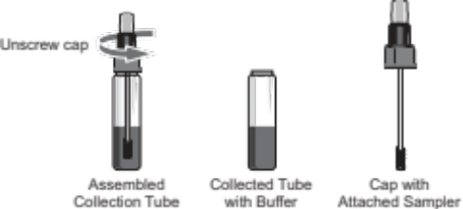
3. Randomly pierce the fecal specimen with the threaded end of the sampler in at least five (5) different sites. Wipe excess feces off the shaft and outer grooves.

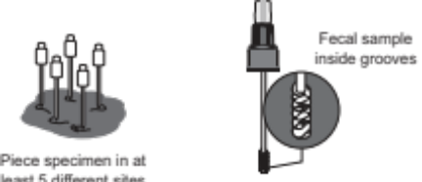

4. Insert sampler in the collection tube and firmly tighten the cap.

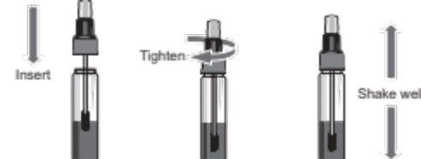

5. Shake the tube well to mix the specimen and the FOB buffer.
NOTE: Samples collected may be stored at least eight (8) days at ambient temperatures below 35°C (95°F), six (6) months at 2-8°C (36-46°F) and two (2) years at ≤ -20°C (≤ -4°F).
ASSAY PROCEDURE
1. Refrigerated specimens or other materials, including the test cassette, must be equilibrated to room temperature before testing.
2. Remove the test cassette from its pouch and place it on a flat surface. Label the device with appropriate identification.



3. Holding the collection tube upright, unscrew the clear tip cover.

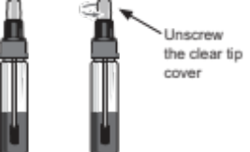

ASSAY PROCEDURE, CONTINUED
4. Squeezing the collection tube, dispense four drops of the FOB buffer in the collection tube into the sample well (“S”).

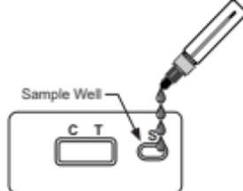

5. Read the result within 5-10 minutes after adding the FOB buffer.
IMPORTANT: Do not read the test results after ten (10) minutes.
INTERPRETATION
POSITIVE:
If both C-line and T-line are present, the result is positive. A positive result indicates the level of hHb in the specimen is over 50 ng hHb/mL FOB buffer or
50 μg hHb/g feces.

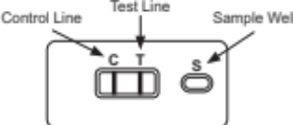

NEGATIVE:
If only the C-line develops in the control region of the test strip, the result is negative. A negative result indicates the hHb in the specimen is below 50 ng/mL.

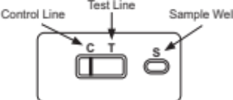
INVALID:
If no C-line appears within 5 minutes, the result is invalid and the assay should be repeated with a new device. NOTE: The test line may or may not be
present. However, the absence of a control line indicates an invalid test.

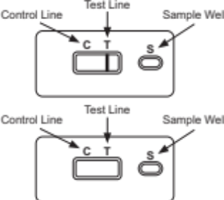

QUALITY CONTROL
• Internal Quality Control
This device contains a built-in control feature, the Control line (C-line). The presence of this C-line indicates that an adequate sample volume was used and that the reagents migrated properly. If a C-line does not form, the test is considered invalid. In this case, review the entire procedure and repeat the testing with a new device.
• External Quality Control
Operators should always follow the appropriate federal, state, and local guidelines concerning the running of external quality controls, including positive and negative, to assure the proper performance of the device.
LIMITATIONS OF THE PROCEDURE
1. Results cannot be considered conclusive evidence of the presence or absence of gastrointestinal bleeding or pathology. A positive result should be followed up with additional diagnostic procedures to determine the exact cause and source of the occult blood in the feces.
2. A negative result can be obtained even when a gastrointestinal disorder is present. For example, some polyps and colorectal cancers may bleed intermittently or not at all during certain stages of the disease.
3. False negative results may occur when occult blood is not uniformly distributed throughout the bowel movement and the formation of a fecal sample. Repeat testing is recommended if a pathological condition is suspected.
PERFORMANCE CHARACTERISTICS
1. Sensitivity
The sensitivity of the test is 50 ng hHb/mL buffer or 50 μg hHb/g feces.
2. Accuracy
• Reference laboratory and Physicians Office Laboratory (POL) Studies
One hundred (100) hHb-free feces extraction specimens collected in-house were divided into 5 groups of 20 each. The five groups of extraction samples were spiked with hHb for five different concentrations, respectively:
0, 37.5 ng hHb/mL, 50 ng hHb/mL, 62.5 ng hHb/mL, and 2000 ng hHb/mL. Those specimens were blind labeled and tested with the Helena Fecal Occult Blood Rapid Test at three (3) Physicians Office Laboratories and a Reference Laboratory.
The results obtained from the three POL sites by persons with diverse
education background and work experiences agreed 97.7% (average) with the expected results. The results obtained from the Reference Laboratory agreed 99% with that expected. Overall, the accuracy of the Helena Fecal Occult Blood Rapid Test is 98%.
• Comparison studies
Those 100 specimens were also tested in house with the Helena Fecal
Occult Blood Rapid Test and a predicate device. The correlation between the Helena Fecal Occult Blood Test and the predicate device was over 95%.
3. Specificity
The Helena Fecal Occult Blood Rapid Test is specific to human hemoglobin. The following substances, when spiked in both positive and negative specimens, did not interfere the test results.

Substance | Concentration (μg/mL)
Beef Hemoglobin | 2,000
Chicken Hemoglobin | 500
Fish Hemoglobin (meat extract) | 100
Horse Hemoglobin | 500
Goat Hemoglobin | 500
Pig Hemoglobin | 500
Rabbit Hemoglobin | 500
Sheep Hemoglobin (meal extract) | 100
Horseradish Peroxidase | 20,000
Red radish | Aqueous extract
Raw turnip | Aqueous extract
Cauliflower | Aqueous extract
Broccoli | Aqueous extract
Parsnip | Aqueous extract
Cantaloupe | Aqueous extract
Vitamin C (ascorbic acid) | Dietary supplement
Iron | Dietary supplement

REFERENCES
1. American Cancer Society, Inc. Cancer Reference lnformation: Can Colon and Rectum Cancer Be Found Early? [Online] Available: http://www.cancer.org
2. Allison JB, Takawa IS, Ransom LJ, Adrian AL. A comparison of fecal occult blood tests for colorectal-cancer screening, N Engl J Med 1996; 334: 155-159.
3. Saito H. Screening for colorectal cancer by immunochemical fecal occult blood testing (Review). Jpn J Cancer Res 1996; 87: 1011-1024.
For Sales, Technical and Order Information and Service Assistance, call 800-231-5663 toll free.
Helena Laboratories warrants its products to meet our published specifications and to be free from defects in materials and workmanship. Helena’s liability under this contract or otherwise shall be limited to replacement or refund of any amount not to exceed the purchase price attributable to the goods as to which such claim is made. These alternatives shall be buyer’s exclusive remedies.
In no case will Helena Laboratories be liable for consequential damages even if Helena has been advised as to the possibility of such damages.
The foregoing warranties are in lieu of all warranties expressed or implied including, but not limited to, the implied warranties of merchantability and fitness for a particular purpose.


Helena Laboratories
1530 Lindbergh Drive
Beaumont, TX 77707 USA

Pro. 4
6/22(3)



