PLEASE READ!!

HELENA LABORATORIES
PROCEDURE DOWNLOAD END USER AGREEMENT

In response to customer requests, Helena is pleased to provide the text for procedural package inserts in a digital format editable for your use. The text for the procedure you requested begins on page three of this document. Helena procedures contain the content outlined in the NCCLS (GP2-A#) format, except in the order sequence required by FDA regulations. As the NCCLS format is a guideline, you may retain these procedures as developed by the manufacturer (adding your title/authorization page) or manipulate the text file to produce your own document, matching the NCCLS section order exactly, if preferred.

We also provide the procedure in an Adobe Acrobat PDF format for download at www.helena.com as a “MASTER” file copy. Below are the specifications and requirements for using these digital files. Following the specifications is the procedure major heading sequence as given in the FDA style. Where there is a difference in order, or other notation in the outline, this will be indicated in braces { }.

WHAT YOU NEED TO KNOW:

1) These files represent the most current revision level to date. Your current product inventory could contain a previous revision level of this procedure.

2) The Microsoft Word document provides the text only from the master procedure, in a single-column format.

- It may not contain any illustrations, graphics or captions that may be part of the master procedure included in the kit.

- The master procedure may have contained special formatting characters, such as subscripts, superscripts, degree symbols, mean symbols and Greek characters such as alpha, beta, gamma, etc. These symbols may or may not display properly on your desktop.

- The master procedures may also contain columns of tabbed data. Tab settings may or may not be displayed properly on your desktop.

3) The Adobe Acrobat PDF file provides a snapshot of the master procedure in a printable 8.5 x 11” format. It is provided to serve as a reference for accuracy.

4) By downloading this procedure, your institution is assuming responsibility for modification and usage.
HELENA LABORATORIES
PROCEDURE DOWNLOAD END USER AGREEMENT

HELENA LABORATORIES LABELING – Style/Format Outline

- PRODUCT {Test} NAME
- INTENDED USE and TEST TYPE (qualitative or qualitative)
- SUMMARY AND EXPLANATION
- PRINCIPLES OF THE PROCEDURE
{NCCLS lists SAMPLE COLLECTION/HANDLING next}
- REAGENTS (name/concentration; warnings/precautions; preparation; storage; environment; Purification/treatment; indications of instability)
- INSTRUMENTS required – Refer to Operator Manual (... for equipment for; use or function; Installation; Principles of operation; performance; Operating Instructions; Calibration* {*is next in order for NCCLS – also listed in “PROCEDURE”}’ precautions/limitations/hazards; Service and maintenance information
- SAMPLE COLLECTION/HANDLING
- PROCEDURE
{NCCLS lists QUALITY CONTROL (QC) next}
9) RESULTS (calculations, as applicable; etc.)
10) LIMITATIONS/NOTES/INTERFERENCES
11) EXPECTED VALUES
12) PERFORMANCE CHARACTERISTCS
13) BIBLIOGRAPHY (of pertinent references)
14) NAME AND PLACE OF BUSINESS OF MANUFACTURER
15) DATE OF ISSUANCE OF LABELING (instructions)

For Sales, Technical and Order Information, and Service Assistance,
call Helena Laboratories toll free at 1-800-231-5663.

Form 364
Helena Laboratories
1/2006 (Rev 3)
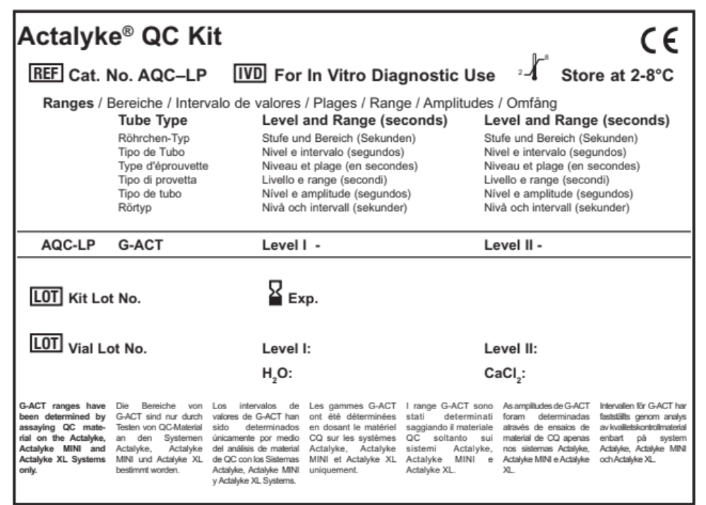

INTENDED USE
The Actalyke QC Kit is a plasma control product intended for performing routine quality control testing of the Actalyke Activated Clotting Time test system. Two product configurations are available to meet different customer needs and to simulate different clinically significant ACT test results. Cat. No. AQC-LP contains Level I and Level II controls and is recommended for QC testing representative of normal and moderately heparinized patient specimens (such as those undergoing ECMO procedures or renal dialysis). Cat No. AQC-HP contains Level I and Level III controls and is recommended for QC testing representative of normal and highly heparinized patient specimens (such as those undergoing cardiovascular procedures).
SUMMARY
Actalyke QC kits are recommended for the verification of proper test system performance combined with operator technique. In the US according to the CLIA ’88 regulations, the frequency of quality control testing is mandated. Since the ACT is categorized as moderately complex, ACT users must (1) perform two levels of quality control during each shift in which the test system is used clinically, and (2) subscribe to a Proficiency Testing program. Additionally, CLIA (42 CFR 493) requires that biological controls be used weekly to verify system function. To help users comply with these regulations, Actalyke QC Kits are available.
Actalyke QC kits are manufactured using non-human plasma and provide results that are similar to those expected clinically, however some differences in values will be observed as compared to whole blood patient samples.
An expected range of values, appropriate to specific Actalyke test tubes, is published for each lot of Actalyke QC kits. This expected range facilitates the analysis of QC results obtained at a given institution, and enables the user to determine if his/her QC results are falling within “acceptable” limits. In addition, a “QC Management Chart” is provided in each Actalyke QC Kit to help users track their quality control test results.
Pipetting options
Syringes with needles or pipettes with plastic tips may be used for reconstitution and dispensing of reagents as follows.
A. Syringes with needles
Lift the seal tab to expose the stopper, leaving the outer ring of the seal in place. Puncture the stopper with the syringe needle, then aspirate or dispense the appropriate amount into each vial.
B. Pipettes with plastic tips
Remove the entire seal and the stopper from the vial. Pipette and dispense the appropriate volume into each vial.
REAGENTS
FOR IN-VITRO DIAGNOSTIC USE
1. Actalyke QC – Level I
Ingredients: The products contain citrated bovine plasma, rabbit brain extracts and buffers. Level I is a normal control for ACT systems.
Preparation for Use: Equilibrate all vials to room temperature before use. Add 1.0 mL of Reconstitution Water to the Actalyke control vial. Swirl gently to mix.
Allow the reconstituted control vial to stand for 5 minutes, swirling it gently at periodic intervals to assure complete reconstitution. At the end of 5 minutes, check material for complete dissolution. Allow to stand longer if not dissolved.
Storage and Stability: The controls should be stored at 2 to 8°C. The room temperature reconstituted product should be used within 1 hour. Unopened vials are stable until the expiration date marked on the vial.
2. Actalyke QC – Level II
Ingredients: The products contain citrated bovine plasma, rabbit brain extracts, porcine heparin, and buffers. Level II is moderately elevated for higher clotting times.
Preparation for Use: Equilibrate all vials to room temperature before use. Add 1.0 mL of Reconstitution Water to the Actalyke control vial. Swirl gently to mix.
Allow the reconstituted control vial to stand for 5 minutes, swirling it gently at periodic intervals to assure complete reconstitution. At the end of 5 minutes, check material for complete dissolution. Allow to stand longer if not dissolved.
Storage and Stability: The controls should be stored at 2 to 8°C. The room temperature reconstituted product should be used within 1 hour. Unopened vials are stable until the expiration date marked on the vial.
3. Reconstitution Water
Ingredients: Deionized Water.
Preparation for Use: Ready for use as packaged.
Storage and Stability: Product should be stored at 2 to 8°C. Equilibrate to room temperature before use. Product is stable until the expiration date marked on the vial.
Sign of Deterioration: Discard if there is any cloudiness or evidence of contamination.
4. Calcium Chloride
Ingredients: 0.02 M calcium chloride.
Preparation for Use: Ready for use as packaged.
Storage and Stability: Product should be stored at 2 to 8°C. Equilibrate to room temperature before use. Product is stable until the expiration date marked on the vial.
Sign of Deterioration: Discard if there is any cloudiness or evidence of contamination.
Procedure
Materials Supplied
Cat. No. AQC-LP (for use with G-ACT tubes)
• 10 X 1 mL Vials of Actalyke QC – Level I – Normal coagulation control.
• 10 X 1 mL Vials of Actalyke QC – Level II – Moderately elevated coagulation control.
• 2 X 10 mL Vials Reconstitution Water – Distilled water.
• 2 X 10 mL Vials Calcium Chloride – 0.02 M calcium chloride.
Contains no human material.
Materials required, not supplied
• Actalyke, Actalyke MINI, or Actalyke XL instrument
• Actalyke ACT test tubes (G-ACT tubes)
• 1.0 mL plastic syringes with needle
or
• 1.0 mL plastic pipette tips
Step-By-Step
Note: Equilibrate all control, water and Calcium Chloride vials to room temperature prior to use.
1. Add 0.25 mL of Calcium Chloride into the G-ACT test tube. Mix well to assure complete dispersion of the activator.
2. Dispense 0.25 mL of the reconstituted control into the G-ACT test tube containing Calcium Chloride.
3. Test the control in the same manner as the patient sample. Refer to the procedural insert packaged with the tubes for detailed instructions.
LIMITATIONS
Failure to obtain results that fall within the expected range of QC values may indicate product deterioration. Other factors that can also affect QC test results include technique and the temperature of the environment and materials used. If a QC test result falls outside the expected range, the test should be repeated using careful technique. If not, a study of each component of the system (i.e., Actalyke QC kit, Actalyke ACT test tube, and Actalyke instrument) should be performed so that the specific problem can be identified and corrected.
PERFORMANCE CHARACTERISTICS
Precision studies were done following NCCLS EP-5 guidelines to determine Within Run and Between Day Precision for 20 days.
G-ACT
Level I Within Run Total Precision
Grand mean 176.7 sec. 176.7 sec.
SD 6.4 9.2
CV% 3.6 5.2

Level II Within Run Total Precision
Grand mean 245.6 sec. 245.6 sec.
SD 10.1 17.2
CV% 4.1 7.0

Level / Stufe / Nivel / Niveau / Livello / Nível / Nivå
Within Run / Innerhalb eines Laufs / Dentro de cada
prueba / Intra-analyse / Entro la serie / Dentro da própria
reacção / Inom körning
Total Precision / Präzision, gesamt / Precisión total
/ Précision totale / Precisione totale / Precisão total /
Sammantagen precision
Grand mean / Gesamtmittelwert / Media grande / Moyenne
totale / Media generale / Média geral /
Totalmedelvärde
Sec. / s / s / s / sec. / seg. / sek.
SD (Standard Deviation) / Standardabweichung /
Desviación Estándar / Ecarts-types / DS / Desvio
padrão / Standardavvikelse
%CV (percentage coefficient of variation) / prozent
variationskoeffizient / porcentaje coeficiente de
variación / coefficient de variation / coefficiente di
variazione in percentuale / coeficiente de percenta
gem de variação / procentuell variationskoefficient
Bibliography / Literatur / Bibliografía / Bibliographie / Bibliografia / Bibliografia / Referenser
1. NCCLS AST2-P, March 1995, Point-of-Care In Vitro Diagnostics (IVD) Testing; Proposed Guideline.
2. Statland B and Westgard J: Quality control: Theory and Practice, Clinical Diagnosis and Management by Laboratory Methods, ed, Henry, J (Philadelphia: WB Saunders Co., 1984) pp. 74-93.
3. Department of Health & Human Services, Center for Laboratories, HSQB, Yost Letter Feb., 15 1996: Electronic Quality Control (QC) Policy; CLIA requirements: 493,1202(e)(4).
4. Colton C: Statistics in medicine (Boston: Little, Brown and Co. 1974) pp. 289-313.


Helena Laboratories
1530 Lindbergh Drive
Beaumont, TX 77707 USA



Form 399-009
5/22(4)

