PLEASE READ!!

HELENA LABORATORIES
PROCEDURE DOWNLOAD END USER AGREEMENT

In response to customer requests, Helena is pleased to provide the text for procedural package inserts in a digital format editable for your use. The text for the procedure you requested begins on page three of this document. Helena procedures contain the content outlined in the NCCLS (GP2-A#) format, except in the order sequence required by FDA regulations. As the NCCLS format is a guideline, you may retain these procedures as developed by the manufacturer (adding your title/authorization page) or manipulate the text file to produce your own document, matching the NCCLS section order exactly, if preferred.

We also provide the procedure in an Adobe Acrobat PDF format for download at www.helena.com as a “MASTER” file copy. Below are the specifications and requirements for using these digital files. Following the specifications is the procedure major heading sequence as given in the FDA style. Where there is a difference in order, or other notation in the outline, this will be indicated in braces { }.

WHAT YOU NEED TO KNOW:

1) These files represent the most current revision level to date. Your current product inventory could contain a previous revision level of this procedure.

2) The Microsoft Word document provides the text only from the master procedure, in a single-column format.

- It may not contain any illustrations, graphics or captions that may be part of the master procedure included in the kit.

- The master procedure may have contained special formatting characters, such as subscripts, superscripts, degree symbols, mean symbols and Greek characters such as alpha, beta, gamma, etc. These symbols may or may not display properly on your desktop.

- The master procedures may also contain columns of tabbed data. Tab settings may or may not be displayed properly on your desktop.

3) The Adobe Acrobat PDF file provides a snapshot of the master procedure in a printable 8.5 x 11” format. It is provided to serve as a reference for accuracy.

4) By downloading this procedure, your institution is assuming responsibility for modification and usage.
HELENA LABORATORIES
PROCEDURE DOWNLOAD END USER AGREEMENT

HELENA LABORATORIES LABELING – Style/Format Outline

- PRODUCT {Test} NAME
- INTENDED USE and TEST TYPE (qualitative or qualitative)
- SUMMARY AND EXPLANATION
- PRINCIPLES OF THE PROCEDURE
{NCCLS lists SAMPLE COLLECTION/HANDLING next}
- REAGENTS (name/concentration; warnings/precautions
- ; preparation; storage; environment; Purification/treatment; indications of instability)
- INSTRUMENTS required – Refer to Operator Manual (... for equipment for; use or function; Installation; Principles of operation; performance; Operating Instructions; Calibration* {*is next in order for NCCLS
- – also listed in “PROCEDURE”}’ precautions/limitations/hazards; Service and maintenance information
- SAMPLE COLLECTION/HANDLING
- PROCEDURE
{NCCLS lists QUALITY CONTROL (QC) next}
9) RESULTS (calculations, as applicable; etc.)
10) LIMITATIONS/NOTES/INTERFERENCES
11) EXPECTED VALUES
12) PERFORMANCE
CHARACTERISTCS
13) BIBLIOGRAPHY (of pertinent references)
14) NAME AND PLACE OF BUSINESS OF MANUFACTURER
15) DATE OF ISSUANCE OF LABELING (instructions)

For Sales, Technical and Order Information, and Service Assistance,
call Helena Laboratories toll free at 1-800-231-5663.

Form 364
Helena Laboratories

1/2006 (Rev 3)

Cat. No. 2400
HELENA TITAN® IV CITRATE HEMOGLOBIN ELECTROPHORESIS

The Helena Titan® IV Citrate Hemoglobin method is intended as a qualitative procedure for the identification of human hemo- globins.

SUMMARY
Hemoglobins (Hb) are a group of proteins whose chief func- tions are to transport oxygen from the lungs to the tissues and carbon dioxide in the reverse direction. They are composed of polypeptide chains called globin, and iron protoporphyrin heme groups. A specific sequence of amino acids constitutes each of four polypeptide chains. Each normal hemoglobin molecule contains one pair of alpha and one pair of non-alpha chains. In normal adult hemoglobin (HbA), the non-alpha chains are called beta. The non-alpha chains of fetal hemoglobin are called gamma. A minor (3%) hemoglobin fraction called HbA2 contains alpha and delta chains. In a hereditary inhibition of globin chain synthesis called thalassemia, the non-alpha chains may aggregate to form HbH (β4) or Hb Bart's (γ4).
The major hemoglobin in the erythrocytes of the normal adult is HbA and there are small amounts of HbA2 and HbF. In addition, over 400 mutant hemoglobins are now known, some of which may cause serious clinical effects, especially in the homozy- gous state or in combination with another abnormal hemoglo- bin. Wintrobe1 divides the abnormalities of hemoglobin synthe- sis into three groups;
- production of an abnormal protein molecule (e.g. sickle cell anemia),
- reduction in the amount of normal protein synthesis (e.g. thalassemia), and
- development anomalies (e.g. hereditary persistence of fetal hemoglobin, HPFH).
The two mutant hemoglobins most commonly seen in the United States are HbS and HbC. Hb Lepore, HbE, HbG- Philadelphia, HbD-Los Angeles, and HbO-Arab may be seen less frequently.2 Electrophoresis is generally considered the best method for separating and identifying hemoglobinopa- thies. The protocol for hemoglobin electrophoresis involves the use of two systems.3-8 Initial electrophoresis is performed in alkaline buffer. Celluloseacetate is the major support medium used because it yields rapid separation of HbA, HbF, HbS and HbC and many other mutants with minimal preparation time. However, because of the electrophoretic similarity of many structurally different hemoglobins, the evaluation must be sup- plemented by citrate agar electrophoresis which measures a property other than electrical charge. This simple procedure requires only minute quantities of hemolysate to provide highly specific (but not absolute) confirmation of the presence of HbS, HbC and HbF, as well as several other abnormal hemoglobins. PRINCIPLE
Very small samples of hemolysates prepared from whole blood are applied to the Titan® IV Citrate Agar Plate. The hemoglo- bins in the samples are separated by electrophoresis using citrate buffer, pH 6.0 to 6.3 and are stained with an o-Dianisi- dine or o-Tolidine staining solution. Separation of hemoglobins under these conditions depends both on the location of the substituted residue and on its electrophoretic charge. The method is based on the complex interactions of the hemoglobin with the electrophoretic buffer (acid pH) and the agar support.

REAGENTS
- Titan® IV Citrate Agar Plates (Cat. No. 2400) Ingredients: Plates contain 1.5% agar (w/v) in 0.03 M citrate buffer with thimerosal added as a preservative. WARNING: FOR IN-VITRO DIAGNOSTIC USE ONLY. Preparation for Use: The plates are ready for use as pack- aged.
Storage and Stability: Plates should be stored flat at 2° to 8°C and are stable until the expiration date indicated on the label. Store in the protective packaging in which the plates are shipped. DO NOT FREEZE THE PLATES OR EXPOSE THEM TO EXCESSIVE HEAT.
Signs of Deterioration: The plates should have a smooth, clear surface. Discard the plates if they appear cloudy, show fungal or bacterial growth, or if they have been exposed to freezing (a cracked or bubbled surface) or excessive heat (a dried, thin surface).

Citrate Buffer (Cat. No. 5121)
Ingredients: Each package of Citrate Buffer contains sodi- um citrate and citric acid.

WARNING: FOR IN-VITRO DIAGNOSTIC USE ONLY. DO NOT INGEST.
Preparation for Use: Dissolve one package of buffer in 1000 mL of deionized water. The buffer is ready for use when all material is dissolved and completely mixed.
Storage and Stability: The packaged buffer should be stored at room temperature (15° to 30°C) and is stable until the expiration date indicated on the package. Diluted buffer is stable for one month at 2° to 8°C.
Signs of Deterioration: Do not use packaged buffers if the material shows signs of dampness or discoloration. Discard diluted buffer if it becomes turbid.

Hemolysate Reagent (Cat. No. 5125)
Ingredients: Hemolysate Reagent is an aqueous solution of 0.005 M EDTA and 0.07% potassium cyanide as hemo- globin preservatives.

WARNING: FOR IN-VITRO DIAGNOSTIC USE ONLY. DO NOT PIPETTE BY MOUTH. HARMFUL IF SWALLOWED.
Preparation for Use: The reagent is ready for use as pack- aged.
Storage and Stability: The reagent should be stored at room temperature (15° to 30°C) and is stable until the expi- ration date indicated on the vial.
Signs of Deterioration: The reagent should be a clear, col- orless solution.

Stains
  - o-Dianisidine (Cat. No. 5036)
Ingredients: 0.2% (w/v) 3,3 dimethoxybenzidine in meth- anol after reconstitution.

WARNING: FOR IN-VITRO DIAGNOSTIC USE ONLY. CARCINOGEN. DO NOT INGEST. AVOID CONTACT
WITH SKIN. The reagent is highly toxic and can cause skin irritation. Should reagent come into contact with skin, wash with copious amounts of water. Harmful if swal- lowed.
Preparation for Use: Dissolve one vial of stain with 1 L methanol.
Storage: The stain should be stored at room temperature (15° to 30°C) and is stable until the expiration date on the vial.

Signs of Deterioration: The reagent should be light yellow- brown. Discard reagent if it becomes dark brown and/or con- tains precipitate.

o-Tolidine (Cat. No. 5041) (may be substituted for o-Dianisidine)
Ingredients: 0.2% (w/v) o-Tolidine in methanol after recon- stitution.

WARNING: FOR IN-VITRO DIAGNOSTIC USE ONLY. SUSPECTED CARCINOGEN. DO NOT INGEST. AVOID
CONTACT WITH SKIN. The reagent is highly toxic and can cause skin irritation. Should the reagent come into contact with skin, wash with copious amounts of water. Harmful if swallowed.
Preparation for Use: Dissolve the contents of one vial with 1 L methanol.
Storage and Stability: The stain should be stored at room temperature (15° to 30°C) and is stable until the expiration date on the vial.
Signs of Deterioration: The reagent should be light yellow- brown. Discard reagent if it becomes dark brown and/or con- tains precipitate.

SPECIMEN COLLECTION AND PREPARATION
Specimen: Whole blood collected in tubes containing EDTA is the specimen of choice.
Specimen Preparation: Specimen hemolysates are prepared as outlined in the STEP-BY-STEP METHOD.
Specimen Storage: Whole blood samples may be stored up to one week at 2° to 8°C.

PROCEDURE
Materials required: The following materials required for the proce- dure are available from Helena Laboratories.
Item | Cat. No.
Zip Zone® Applicator | 4080
Zip Zone® Sample Well Plate (2) | 4081
Titan IV Aligning Base | 4083
Titan Gel Electrophoresis Chamber | 4063
Microdispenser and Tubes | 6008
Zip Zone® Sponge Wicks | 9014
Titan Plus Power Supply | 1504
Titan® IV Citrate Agar Plates | 2400
Citrate Buffer | 5121
AFSC Hemo Control | 5331
o-Dianisidine | 5036
o-Tolidine | 5041
Hemolysate Reagent | 5125
Blotter Pads (76 x 102 mm) | 5034
Helena Marker | 5000

STEP-BY-STEP METHOD
- Preparation of Titan® IV Citrate Agar Plate
  - Remove the Titan® IV Citrate Agar Plate from the refrigerator and allow the plate to come to room temperature (15 to 30°C) while preparing the patient samples.
  - Remove the plate from the plastic bag and properly identify it by marking with a marker on the plastic support backing of the agar filled half of the plastic plate. Place the mark in one corner so that it will be aligned with sample No. 1.

Preparation of Patient Sample and the Control
  - To prepare a hemolysate of the patient sample, add one (1) part of whole blood to 19 parts Hemolysate Reagent. Alternatively, if removal of denatured hemoglobins from the sample is deemed necessary; washed cells should be used.
    - Centrifuge the blood sample at 3500 RPM for 5 minutes.
    - Remove the plasma from the sample and wash the red blood cells in 0.85% saline (v/v) three times. After each wash, centrifuge the cells for 10 minutes at 3500 RPM.
    - Add 1 volume deionized water and 1/4 volume toluene (or carbon tetrachloride) to the washed red cells. Vortex at high speed for one minute. Centrifuge the samples at 3500 RPM for 10 minutes.
    - If toluene is used, the top layer in the tube will contain cell stroma and should be removed with a capillary pipette before proceeding to the next step. The clear middle layer contains the desired sample. If carbon tetrachloride is used, all red cell waste material will be contained in the bottom of the tube after centrifugation.
    - Filter the clear red solution through two layers of Whatman #1 filter paper.
  - Prepare the AFSC Hemo Control by adding one (1) part of the control to one (1) part Hemolysate Reagent.
  - Mix all hemolysate preparations well. Cover the tubes and allow to stand for five (5) minutes.

Materials needed but not supplied:
Hydrogen peroxide (3%)
Glacial acetic acid (Dilute 5 parts with 95 parts deionized water,

Preparation of Titan Gel Chamber
  - 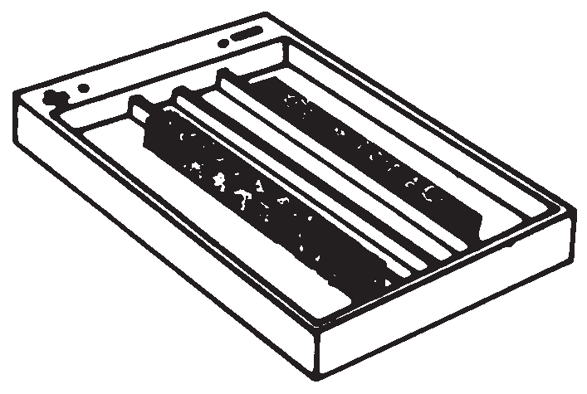Pour approximately 100 mL of Citrate Buffer into each outer section of the Titan Gel Chamber.
  - Wet two sponge wicks in the buffer, and place the sponges in each outer compartment so that the top surface protrudes approximately 2 mm above the inner chamber ridges. (Care should be taken to rinse all buffer from the sponges before each use.) Gently press the sponge to assure complete saturation with buffer.

Sample Application
Sponge Wicks

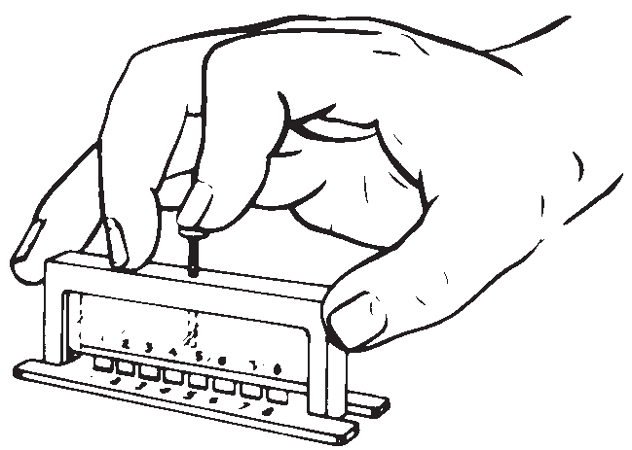

to yield 5% solution.) Absolute Methanol
1% Sodium nitroferricyanide
SUMMARY OF CONDITIONS
Plate .............................................. Titan® IV Citrate Agar
Buffer........................... Citrate Buffer diluted to 1000 mL
Sample volume (Hemolysate)................................... 5μL
Application point.................................................... Anode
Number of applications ........................one (1) or two (2)
Electrophoresis time ......................................45 minutes Voltage .................................................................... 50 V Staining time ...........................................5 to 10 minutes
  - Mix the hemolysate solutions once more to ensure complete lysis.
  - Place 5 μL of each prepared hemolysate (patient and control) in separate wells of the Zip Zone® Sample Well Plate using the Microdispenser. Cover the Sample Well Plate with a glass slide if the samples are not used within 2 minutes.
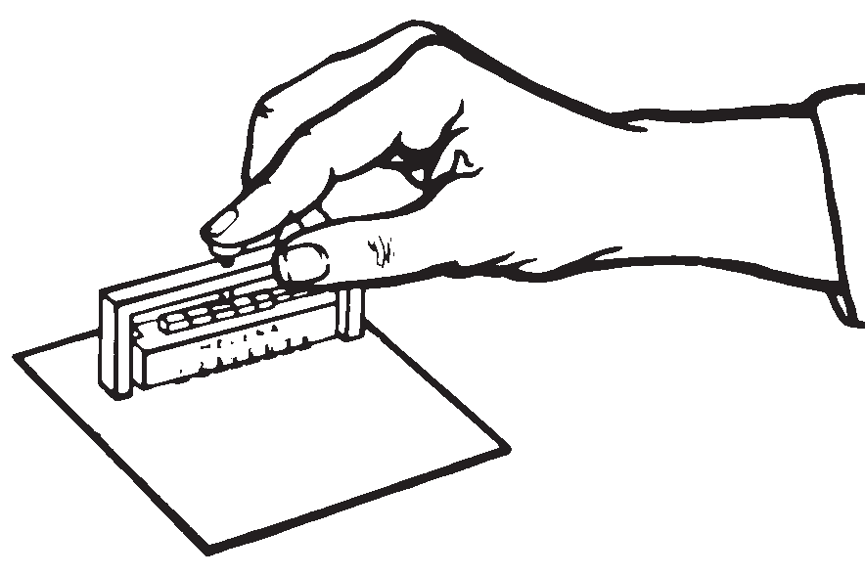
  - To prime the Zip Zone® Applicator, quickly press the tips into the sample wells 3 or 4 times and apply to a blotter. Priming the applicator makes the second loading more uniform. Do not load the applicator again at this point,
but proceed quickly to the next step.

  - Remove the cover from the Titan® IV Citrate Agar Plate. Position the plate in the Titan IV Aligning Base. The identification mark should be aligned with sample No. 1.
  - If desired, the spring can be removed from the applicator, allowing the applicator to rest
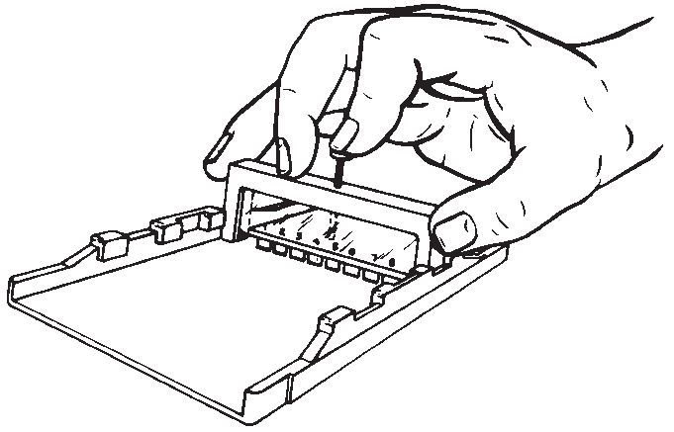
upon the agar without cutting

RESULTS
Figure 1 illustrates how a comparison of Citrate Agar and Cellulose Acetate plates can eliminate possible hemoglobins. Figure 2 lists the relative mobilities of various hemoglobin mutants on cellulose acetate and citrate agar plates.

into it. To apply the sample to the plate, press the applicator tips into the sample wells 3 or 4 times and promptly transfer the applicator to the first set of stanchions on the Titan IV Aligning Base. Gently press the
applicator tips down onto the gel surface. Allow the samples to soak into the agar for about one minute. To run 16 sam- ples on one plate, use a second Zip Zone® Sample Well Plate and fill the wells with a second set of hemolysates (patient and control). Using a clean Zip Zone® Applicator, place the applicator in the second set of stanchions on the Titan IV Aligning Base and apply the samples to the plate in the same manner as before.

Electrophoresis of the Sample Plate
  - Quickly put the plate, agar side down, in the Titan Gel Chamber so that the agar layer makes good contact with the top surface of the sponges. The first application point should
(+) Cellulose Acetate
(-)
(+)
Citrate Agar

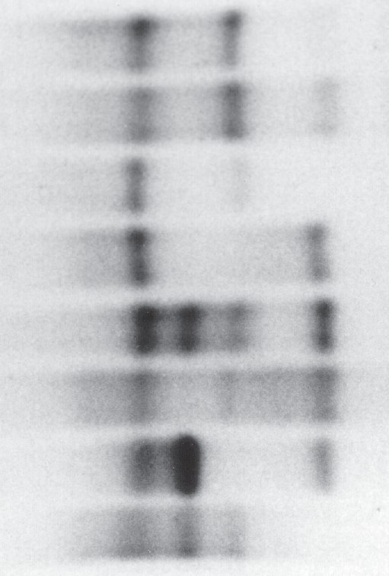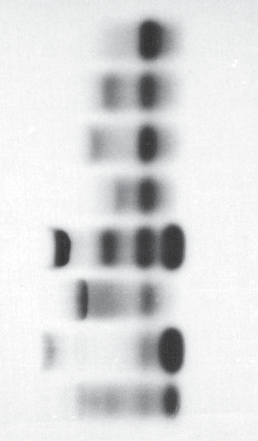C S A F A2 D E

A F S A2
D C
G E
Application Point O
(-)

AD Los Angeles AS-G Philadelphia A Hasharon
AO-Arab AFSC Control AE
FAC FAS

be nearest the anode (+).
  - Place the lid on the chamber and ensure that it is completely seated.
  - Electrophorese for 45 minutes at 50 volts. Electrophoresis time may be increased to 60 minutes, if additional separation of HbS from the application point is desired.

Visualization of the Hemoglobin Bands
  - Prepare the staining solution while electrophoresis is in progress. The reagents in this staining solution should be kept in separate bottles, mixed just prior to use, and discarded after each use. Prepare the staining solution as follows:
5 mL 0.2% o-Dianisidine (o-Tolidine may be substituted) 10 mL 5% acetic acid
1 mL 3% hydrogen peroxide
1 mL 1% sodium nitro ferricyanide
  - Upon completion of electrophoresis, remove the plate from the chamber and place on the counter top, agar side up.
  - Puddle the stain over the entire surface of the plate and stain for 5 to 10 minutes. Plates may also be immersed in the stain, but a greater volume of stain is required.
  - The hemoglobins present in the patient samples should be identified by comparison to the migration pattern of the AFSC Hemo Control. For immediate visualization, pour off the stain.
  - If permanent storage is desired:
- Wash in 5% acetic acid for 30 minutes.
- Rinse in deionized water for 10 minutes.
- Hold the plate under gently running water.
- Cut the agar in half, then slide a 3 x 5 card under the stained half of the agar and remove it from the holder.
- Flood the agar surface with 2% glycerol for 35 minutes.
- Tilt and drain the plate onto a blotter for 2 minutes.
- Lay the plate on a fresh blotter, then dry at 50°C for 1 hour and 20 minutes or dry at 37°C for 3 to 4 hours.
- Add an I.D. label.
Stability of End Product: The unpreserved plates are stable for three months if kept tightly closed. Dried plates are stable indefinitely.
Quality Control: The Helena AFSC Hemo Control (Cat. No. 5331) should be run on each Titan® IV Citrate Agar Plate. The control verifies all phases of the procedure and acts as a marker to aid in the identification of the hemoglobins in the unknown samples.
G Methemoglobin
Figure 1. Electrophoretic Mobilities of Hemoglobins on Titan® III Cellulose Acetate and on Titan® IV Citrate Agar.

O Arab - Migration varies on citrate agar from Hemoglobin A through Hemoglobin S. J Baltimore - Trait is approximately 50% of the total.
J Oxford - Trait is approximately 25% of the total.
*Unstable hemoglobin
D Los Angeles and D Punjab are the same hemoglobin. C Harlem and Georgetown are the same hemoglobin.
Köln is broadly smudged on both media possibly due to instability.

 | Cellulose Acetate |  |  |  |  |  |  |  | Citrate Agar
 | + 0 -2.6 -5.2 -10 – A F S A2 |  |  |  |  |  |  |  | – -4.4 -0 +5.8 +10 + F A S C
S |  |  |  |  |  | -5.2 |  |  |  |  |  |  | +5.8
C |  |  |  |  |  |  |  | -10 |  |  |  |  |  |  | +10
*E |  |  |  |  |  |  |  | -10 |  |  |  | 0
Lepore |  |  |  | -5 |  |  |  |  |  |  |  | 0
G Philadelphia |  |  |  | -5.2 |  |  |  |  |  |  |  | 0
D Punjab |  |  |  | -5.2 |  |  |  |  |  |  |  | 0
O-Arab |  |  |  |  |  |  |  | -9.7 |  |  |  | +1.7
*Hasharon |  |  |  |  |  | -5.5 |  |  |  |  |  | +6.25
H | +8.5 |  |  |  |  |  |  |  |  |  |  | 0
Constant Spring |  |  |  |  |  |  |  | -11.9 |  |  |  | 0
Malmo | +0.5 |  |  |  |  |  |  |  |  |  |  | -1.1
A2' |  |  |  |  |  | -11.1 |  |  |  |  |  | 0
Wood | 0 |  |  |  |  |  |  |  |  |  |  | -2.25
Barts | +7.6 |  |  |  |  |  |  |  |  | -4.0
*Köln |  |  |  |  |  |  |  | -7.5 |  |  |  | -2.5
N Baltimore | +6.6 |  |  |  |  |  |  |  |  |  |  | 0
ASG Philadelphia | 0 |  |  | -5.2 |  | -10 |  |  |  |  |  | 0 | +5.8
J Oxford | +4.6 |  |  |  |  |  |  |  |  |  |  | 0
J Baltimore | +4.3 |  |  |  |  |  |  |  |  |  |  | 0
*Tacoma | +0.9 |  |  |  |  |  |  |  |  |  |  | 0
*Lufkin |  |  | +3.2 |  |  |  |  |  |  |  |  | 0
*Camperdown |  |  |  |  |  |  |  |  |  |  |  | 0
K | +0.8 |  |  |  |  |  |  |  |  | -4.0
Hope | +0.8 |  |  |  |  |  |  |  |  | -4.0
Camdem |  |  | +1.6 |  |  |  |  |  |  |  |  | -2.8
New York |  |  | +1.5 |  |  |  |  |  |  |  |  | 0
*G San Jose |  |  | -3.6 |  |  |  |  |  |  |  |  | +7.5
C Harlem |  |  |  |  |  |  |  | -10.0 |  |  |  | +5.8

Figure 2. Relative Electrophoretic Mobilities of Hemoglobins on Cellulose Acetate and Citrate Agar.9

REFERENCE VALUES
At birth, the majority of hemoglobin in the erythrocytes of the normal individual is fetal hemoglobin, HbF. Some of the major adult hemoglobin, HbA, and a small amount of HbA , are also

REFERENCES
- Wintrobe, M.M., Clinical Hematology, 6th Edition, Lea and Febiger, Philadelphia, 1967.
- Fairbanks, V.F., Diagnostic Medicine Nov/Dec.:53-58, 1980.

present. At the end of the first year of life and
2
through
adult-
- Schneider, R.G., et al. Laboratory Identification of the

hood, the major hemoglobin present is HbA with up to 3.5% HbA2 and less than 2% HbF.

INTERPRETATION OF RESULTS
Hb Electrophoresis
Citrate agar electrophoresis is a necessary followup test for confirmation of abnormal hemoglobins detected on cellulose acetate. Hemoglobins are genetically controlled, and the pres- ence of abnormal hemoglobins is often associated with func- tional, physical and morphologic abnormalities in the erythro- cyte, as well as pathological manifestations, such as hemolytic anemia.

Sickle Trait
This is a heterozygous state showing HbA and HbS and a nor- mal amount of HbA2 on cellulose acetate. Results on citrate agar show hemoglobins in the HbA and HbS migratory positions (zones).

Sickle Cell Anemia
This is a homozygous state showing almost exclusively HbS, although a small amount of HbF may also be present.

Sickle-C Disease
This is a heterozygous state demonstrating HbS and HbC.

Sickle Cell - Thalassaemia Disease
This condition shows HbA, HbF, HbS and HbA.2
Hemoglobins, Lab Management, August, 29-43, 1981.
- Center for Disease Control, Laboratory Methods for Detecting Hemoglobinopathies, U.S. Department of Health and Human Services/Public Health Service, 1984.
- Schneider, R.G., Methods for Detection of Hemoglobin Variants and Hemoglobinopathies in the Routine Clinical Laboratory, CRC Critical Reviews in Clinical Laboratory Sciences, 1978.
- Schneider, R.G., et al., Abnormal Hemoglobins in a Quarter Million People, Blood, 48(5):629-637, 1976.
- Huisman, T.H.J. and Schroeder, W.A., New Aspects of the Structure, Function, and Synthesis of Hemoglobins, CRC Press, Cleveland, 1971.
- Schmidt, R.M., et al., The Detection of Hemoglobinopathies, CRC Press, Cleveland, 1974.
- Personal communication from Dr. Virgil Fairbanks.
For Sales, Technical and Order Information and Service Assistance, call 800-231-5663 toll free.
Helena Laboratories warrants its products to meet our published specifications and to be free from defects in materials and workmanship. Helena’s liability under this contract or otherwise shall be limited to replacement or refund of any amount not to exceed the purchase price attrib- utable to the goods as to which such claim is made. These alternatives shall be buyer’s exclu- sive remedies.
In no case will Helena Laboratories be liable for consequential damages even if Helena has been advised as to the possibility of such damages.
The foregoing warranties are in lieu of all warranties expressed or implied including, but not lim- ited to, the implied warranties of merchantability and fitness for a particular purpose.

In Sickle Cell β°-Thalassemia HbA is absent.
In Sickle Cell β+-Thalassemia HbA is present in reduced quantities. Thalassaemia-C Disease
This condition shows HbA, HbF, and HbC. C Disease This is a homozygous state showing almost exclusively HbC. Thalassaemia Major
This condition shows HbF, HbA and HbA.2

LIMITATIONS
Some abnormal hemoglobins have similar electrophoretic mobilities and must be differentiated by other methodologies such as solubility tests and sickling or heat tests.

Further testing:
- Globin chain analysis (both acid and alkaline) and structural studies may be necessary for positive identification.5
- Low levels of HbF (1% to 10%) may be accurately quantitat- ed using any commercially available HbF method.

Shaded areas indicate that text has been modified, added or deleted.
Beaumont, Texas USA 77704

Pro. 17
6/17 (6)

